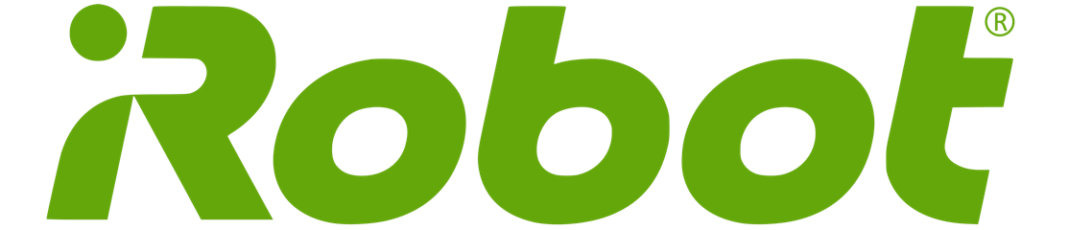

**Company Evaluation**

**James Edstrom**

**Taylor Field**

**Micah Stark**

**Basic Information**

iRobot (IRBT) is a company within the appliance industry publically traded on the Nasdaq since 2005 when its IPO price was $24/share. Currently, shares are trading for $84.35 which is overvaluing iRobot once the drastic change in competitors and elimination of their commercial business is factored in. The target stock price is $41.35 which leaves iRobot overvalued by $43.00/share. The market will make pricing adjustments more efficiently once iRobot’s revenues over the next couple of quarters flatten out as competition steals away market share currently controlled by iRobot.

At the current stock price, iRobot has a market capitalization of $2.1 Billion.

iRobot operates in the appliance industry specifically in robotic home care products. iRobot’s main product line is the Roomba, its robotic vacuum, where over 90% of the market is currently controlled by iRobot. However, the market share dominance currently enjoyed by iRobot will quickly evaporate in the coming year as new competitors such as Samsung, LG, Dyson and Neato all focus on the same expanding market, the robotic vacuum. Notably, both Samsung and LG are substantially larger competitors (150x and 6.23x by market capitalization) whom are new to the space but carry significantly more brand recognition across broad consumers.

iRobot’s main product line: the Roomba

Currently, 81.87%% of iRobot’s shares are held by institutional and Mutual Fund Owners including (in order of shares owned): Vanguard Group (8.58%), BlackRock Fund Advisors (7.89%), Lord Abett & Co (5.3%), and Columbia Wanger Asset Management, L.P. (4.60%). The only significant holding from Direct Holders is the Chief Executive and founder, Colin Angle whom controls $31M shares. Interestingly in the past 9 months, Colin Angle has liquidated 19% of shares reducing his control from $39M to $31M.

**Business Description**

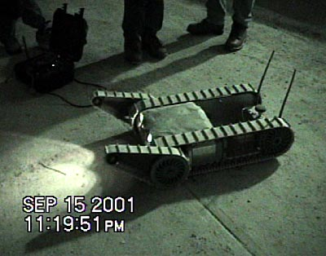iRobot designs and builds robots that empower people to do more. iRobot’s main product line is the Roomba robotic vacuum which allows owners to take a very hands off approach to keeping their carpet and hard floors clean. For just over 20 years, iRobot also provided robots for military defense along with space and ocean exploration. However, within the last year; iRobot made the strategic decision to focus upon the consumer as their customer and eliminated both the commercial and government aspects of their business model. In a further effort to focus on the consumer as their customer, iRobot has created and is developing new product lines including robotic floor mopping, pool cleaning and even robotic lawn care.

iRobot was founded back in 1990 by current Chief Executive Colin Angle, an MIT roboticist. Originally in the 1990s, iRobot focused upon robots that were designed for space exploration, eliminating mines in surf zones and even a robot designed for searches at the World Trade Center following the September 11 terrorist attacks. In 2002, iRobot developed their first robotic vacuum, the Roomba, and the transition towards a consumer based product began. Since first offering consumer robots 15 years ago, iRobot has sold over 18 million consumer robots. In the North American market, iRobot currently controls 89% of the robotic vacuum segment. Internationally, iRobot holds the largest market share of any single company with the robotic vacuum segment, as well. Looking forward, iRobot is focused on enhancing their product line through the internet of things by connecting all of their products to their consumer’s phones and other smart devices. iRobot projects from 2015 to 2017, sales of their connected robots will increase from 100,000 to 2.1 million.

iRobot’s PackBot searching the World Trade Center remains for survivors

As previously mentioned, iRobot also has developed a mopping robot product line named the Braava jet in 2016. While the Roomba robotic vacuum currently holds a very strong grip on the robotic vacuum market, the Braava is still in its early growth phase as the market segment is only beginning to develop itself. One interesting aspect for additional revenue stemming from the Braava jet is the need to purchase pads periodically in order to continue using the product. Even once the consumer has purchased the Braava jet, the consumer still needs to continue purchasing products from iRobot which are high in margin. Another growth opportunity iRobot is focusing upon in the next couple of years is its robotic lawn mower. However, due to radio frequency regulations by the FCC; iRobot is stuck spending time with legalities instead of developing and marketing their product.

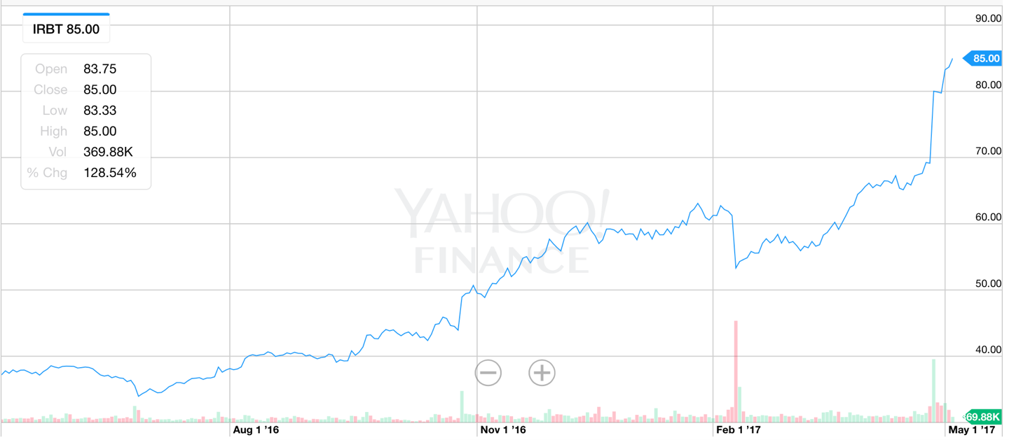 Currently iRobot share’s sell for $84.35 with a market capitalization of $1.7 Billion. As shown below in the last year, iRobot stocks have grown in value by 85.05%; while YTD iRobot shares are up 6.91%. Furthermore, since iRobot was originally evaluated in the fall of 2015, iRobot has nearly doubled in market capitalization and the stock price has surged by 99%. However, as iRobot faces drastically increased competition and has eliminated a steady aspect of their business model, commercial application; future growth will be challenging.

iRobot (IRBT) stock performance over last 1 year

**Management and Governance**

iRobot has been under the control of Colin M. Angle who serves as Chairman of the Board, Chief Executive Officer and Director since 1992 when iRobot was originally created. iRobot has two Executive Vice Presidents, Alison Dean and Russell Campanello. Alison Dean has been with iRobot since 2005 when she left her Vice President position at 3Com, a digital electronic manufacturer. Russell Campanello has been with iRobot since 2010 when Phase Forward, the company at which he served as Senior Vice President, was purchased by Oracle. Finally, Christian Cerda currently serves as the Chief Operating Officer, and has experience in marketing, product management and manufacturing from Whirlpool Corporation.

The executive team’s compensation has increased over the last couple of years which is most likely due to much of the executive team’s compensation stemming from stock options. Since the stock has performed well over the last couple of years, the value of these stock options has drastically increased. Total annual compensation for the executive is not extravagant as the CEO made $3.56M in 2014, along with each other executive team member making just over $1M annually.

|  |  |
| --- | --- |
| **Largest Institutional Investors** |  |
| Vanguard Group | 8.58% |
| BlackRock Fund Advisors | 7.89% |
| Lord Abett & Co | 5.30% |
| Columbia Wanger Asset Management | 4.60% |

Another aspect of iRobot’s governance that cannot be ignored is the high level of institutional investors that have the ability to “guide” iRobot unlike an individual investor. 81.87% of all iRobot shares are owned by institutional owners, while the largest 5 institutional investors own just over 30% of all shares outstanding.

iRobot has a track record of a very stable executive team and tends to promote from within. However, the board and the executive team have both been controlled by the founder for 25 years. As previously mentioned, Colin Angle has recently eliminated 20% of his holdings of iRobot which may be a sign of potential concerns from within iRobot. Furthermore under Colin Angle’s direction, iRobot originally focused on commercial and governmental aspects of their robot business. However, recently iRobot has sold off this aspect of their business which historically has provided a steady and reliable stream of income.

**Industry Overview and Competitive Positioning**

iRobot currently controls almost the entire robotic vacuum market; however, with Samsung, LG, and Dyson all recently jumping into the market; this strength of iRobot’s will disappear. Competition has been very absent in the robotic market to date; however, Samsung launched four new robotic vacuums prior to holiday season 2016 which sold extremely well even though they were often at a higher price point than iRobot’s options. Since Dyson is still a private business, and both LG and Samsung are conglomerates both based out of South Korea; financials are either unavailable or incomparable to iRobot’s. However, SodaStream International (NASDAQ: SODA) which creates products to instantaneous create carbonated beverages shares a few characteristics with iRobot including market cap, market dominance and the more broad appliance industry both firms compete within.

The following table summarizes the key ratios of both companies.

|  |  |  |  |
| --- | --- | --- | --- |
| **iRobot** |  | **SodaStream** |  |
| P/E | **43.12** | P/E | **26.64** |
| Price/Book | **5.69** | Price/Book | **2.9** |
| Gross Profit Margin | **50.4%** | Gross Profit Margin | **54.3%** |
| Revenue Growth (Quarterly YoY) | **28.80%** | Revenue Growth (Quarterly YoY) | **6.4%** |

A trend begins to emerge when comparing iRobot and SodaStream. Beginning with Price/Earnings, Price/Book, and Price/Cash Flow; investors are willing to pay more for iRobot’s business than SodaStream. Since SodaStream currently enjoys a higher gross profit margin and is growing revenue twice as fast as iRobot is; iRobot is overpriced. Even though a higher P/E, Price/Book, and Price/Cash Flow can be a positive sign of investor confidence, iRobot’s plateau in growth and lower gross profit margin compared to SodaStream are signs of overpricing.

**Valuation Model**

For the valuation model, iRobot is planning to grow 15% in the next year for entering into the China market. IRobot does not pay any dividends meaning they are reinvesting in themselves. IRobot is no longer accepting defense and security contracts with the military, which was about 10% of their revenues historically. The elimination of their commercial division will lower iRobot’s cost of Research and Development. iRobot will keep growing but in the next few years, we do expect iRobot’s growth rate to slow down and in the table on the next page are the projected revenues for iRobot. iRobot does have potential to growth but at what rate can iRobot grow for the next 10 years. iRobot needs to have a few consecutive years of 15% growth or a geometric average growth of 8% in order to have a $50.00 stock valuation. IRobot has nearly 210 million in cash on the balance sheet. The idea is iRobot will be using that for a future project in order to increase their growth sporadically over the next 10 years. The discount rate for this company was 10.19%, which brings down the value of the Net Present Value along with the stock price.

10 year Forecast in millions

|  |  |  |  |  |  |  |  |  |  |  |  |
| --- | --- | --- | --- | --- | --- | --- | --- | --- | --- | --- | --- |
| Year | **2016** | **2017** | **2018** | **2019** | **2020** | **2021** | **2022** | **2023** | **2024** | **2025** | **2026** |
| Growth % |  | 15% | 15% | 15% | 10% | 10% | 7% | 7% | 7% | 7% | 5% |
| **Revenue** | **605** | **695** | **799** | **919** | **1,011** | **1,112** | **1,190** | **1,274** | **1,363** | **1,458** | **1,531** |
| Cost of Product Revenue | 327 | 344 | 392 | 451 | 500 | 546 | 584 | 630 | 669 | 716 | 758 |
| **GM** | **278** | **351** | **407** | **468** | **511** | **567** | **606** | **643** | **694** | **743** | **773** |
| Home Robots Margin | 49% | 49% | 49% | 49% | 49% | 49% | 49% | 49% | 49% | 49% | 49% |
| R&D | 80 | 92 | 106 | 122 | 124 | 126 | 135 | 144 | 154 | 165 | 173 |
| Selling and Marketing | 115 | 135 | 155 | 179 | 176 | 194 | 208 | 222 | 238 | 254 | 267 |
| G&A | 67 | 69 | 79 | 91 | 95 | 105 | 112 | 120 | 128 | 137 | 144 |
| **Total Operating Expenses** | **262** | **296** | **341** | **392** | **396** | **424** | **454** | **486** | **520** | **556** | **584** |
| Operating Income | 62 | 58 | 67 | 77 | 120 | 143 | 153 | 164 | 175 | 187 | 197 |
| Other Income | 4 | 5 | 4 | 4 | 4 | 4 | 4 | 4 | 4 | 4 | 5 |
| EBT | 66 | 63 | 71 | 81 | 124 | 147 | 157 | 168 | 180 | 192 | 201 |
| Taxes | 19 | 19 | 21 | 20 | 31 | 37 | 39 | 42 | 45 | 48 | 50 |
| **Net Income** | **47** | **44** | **49** | **61** | **93** | **110** | **118** | **126** | **135** | **144** | **151** |
| EPS | 1.68 | 1.54 | 1.73 | 2.12 | 3.26 | 3.86 | 4.13 | 4.41 | 4.71 | 5.03 | 5.28 |
| Shares | 28 | 29 | 29 | 29 | 29 | 29 | 29 | 29 | 29 | 29 | 29 |

**Growth Rate**

The past five years the geometric average of growth has been 7.25% and having a cumulative Free Cash Flow for the past five years of 1.912 million dollars. The historical data sets gave us a little idea in how volatile iRobot has been throughout the years. iRobot released in their press release they are planning to grow 15% in the next year. If iRobot can do achieve this growth rate then their stock price will spike up even a lot higher than expected.



**Sensitivity Analysis**

In the sensitivity analysis, the Beta, Cost of Equity, and the Geometric Growth of the revenues were adjusted by 10%. The model shows decreasing the beta will increase the stock price by 13%, and increasing the beta by 10% will decrease the stock price by 12%. IRobot is not the only company that makes robotics vacuum cleaners. While we are saying this company is overvalued around 20 dollars if IRobot is going at the rate it has been going. The sensitivity analysis gave us a better idea if we started changing the Beta, Cost of Equity, and changing the growth geometric average. Changing the coast of equity shows how much the stock price can fluctuate. Another thing that can drop the stock price would be watching other companies coming into this market and doing the same exact thing for a much cheaper price. One of the companies that would be a big risk to IRobot would be Samsung for how well known for their products and how much cash they have.

|  |  |  |
| --- | --- | --- |
| Sensitivity Analysis | | Firm Value |
| **Beta** | **1.08** | **44.41** |
| Increase by 10% | 1.19 | 39.11 |
| Decrease by 10% | 0.98 | 50.23 |
| **Cost of Equity** | **10.18%** | **44.41** |
| Increase by 10% | 11.20% | 37.66 |
| Decrease by 10% | 9.25% | 52.23 |
| **Growth GeoMean** | **7.473%** | **44.41** |
| Increase by 10% | 8.22% | 49.00 |
| Decrease by 10% | 6.79% | 40.58 |

We also looked at a few other factors in evaluating this company towards another company and the industry average. IRobot gross margin would be considered great vs the industry average. When looking at growth rates it does look like IRobot is almost at maturity stage while the industry growth is about six times as much as IRobot.



**Conclusion**

Calculating the discount rate was the biggest factor in figuring out the Net Present Value for IRobot. The shares outstanding is 27 million and about 16% of those shares are being shorted. Concluding that there could be a lot of speculation in people buying this stock. Some websites are concluding that the target stock price for this company should be around $56.60.

