Steris PLC

Equity Research Report

By: Mitchell Johnson & Chelsi Nahrgang

Basic Information

Steris PLC is a firm that manufactures surgical appliances. The company supplies surgical equipment, hand sanitizers, sterilization systems, sterile processing solutions, laboratory medical equipment, and equipment decontamination systems. Steris caters to the healthcare, pharmaceutical, defense, biotechnology, and industrial sectors worldwide. Steris stock trades primarily on the New York Stock Exchange (NYSE) under the ticker symbol STE in the Health Care Equipment & Services industry. The current stock price is $68.63, and has a market capitalization of about $5.837 billion. Steris’s has a group of major investors who own approximately 42.82% of shares. The top five investors are Janus Capital Management LLC who own 8.56 million shares or 10.05%, The Vanguard Group, Inc. who owns 7.09 million shares or 8.33 %, BlackRock Fund Advisors who own 4.56 million shares or 5.35%, Iridian Asset Management LLC who owns 3.92 million shares or 4.60%, and Westfield Capital Management Co. LP who owns 2.44 million shares or about 2.86%.

Investor | % Share Ownership
Janus Capital Management LLC | 10.05%
The Vanguard Group, Inc. | 8.33%
BlackRock Fund Advisors | 5.35%
Iridian Asset Management LLC | 4.60%
Westfield Capital Management Co. LP | 2.86%

Investment Summary

Steris had a dividend of $.98 in 2016, which was an 8.98% increase from 2015. Of the 8 analysts covering the company, 3 recommended a buy, 3 recommended it would outperform the market, and 2 recommended a hold. Dividends are expected to reach $1.09 in 2017, which would be a 10.71% increase. This consistent dividend growth (and expected growth) is a sign that management is confident in its financial strength moving forward. Steris’s share price has a 12-month price target median of about $82, a high estimate of $94, and a low estimate of $70. The consensus among analyst covering the firm show that the share price is currently undervalued, and there will be a positive correction in the market in the next 12 months.

Steris liquidity seems to be strong when compared to its direct competitors, with a current ratio of 2.428. Ecolab’s current ratio is about 1.42, Kimberley Clark’s is .85, and Cantel Medical’s about 2.31. Having a strong liquidity measure compared to their competitors is important because that means that they will have easily accessible money for things like R&D which is important for medical device manufacturers.

Business Description (all dollars in thousands)

Steris’s business is composed of four major sectors: Healthcare Products, Healthcare Specialty Services, Life Sciences, and Applied Sterilization Technologies.
Healthcare Products is the largest sector of Steris’s business, with revenues of $1,207,158, which is a 5.6% increase from 2015. Healthcare Specialty Services is the second largest business sector with revenues of $422,860, which was a 70.1% from 2015. This 70.1% increase was a result of the acquisition of Synergy Health combined with a 11% growth in legacy operations. These two sectors are often intertwined and can be broken down into the types of products and services it offers, the first of which is surgical. Surgical products include Surgical Tables and Lights, AMSCO Warming Cabinets, Surgical Table Accessories, Surgical Booms, OR integration Systems, Scrub Sinks, Surgical and Wall Displays, Operating Room Storage Solutions, Nurse Documentation Stations, and Hybrid OR. The next Healthcare Product is Perioperative Solutions. These products include RealView Visual Workflow Management Software, SAFE Situational Awareness for Everyone Display, CS-iQ Sterile Processing Workflow Management Software, STERIS Professional Services Group, Harmony iQ Perspectives Image Management System, Analytics iQ OR utilization Service. Sterile processing is the next component of Healthcare Products. This group of products includes Steam Sterilizers, Washing and Decontamination Systems, V-PRO Low Temperature Sterilization Systems, Biological Indicators, Chemical Indicators, Surgical Instrument Cleaning Chemistries, SPD Accessories, CS-iQ Sterile Processing Workflow management Software, and STERIS Professional Services Group. Next, this sector includes Infection Prevention, which has products like Hand Sanitizers, Lotions and Soaps, Hand Hygiene Compliance Systems, Washing and Decontamination Systems, Cleaners and Disinfectants, Ready to Use Disinfectants, UV Disinfection Systems, and Equipment Decontamination. Endoscope Reprocessing is the next product category. This category includes Liquid Chemical Sterilant Processing System, Endoscope Detergents and High Level Disinfectants, and High Level Disinfections Systems. The Last product category includes an Ambulatory Surgery Center, SecureCare Service, Planning and Design, and Certified Pro-owned Equipment.
The third major sector of Steris is Life Sciences, which had revenues of $295,970 and a 18% increase from 2015. Life Science Products includes Detergents, Surface Disinfectants, Cleaners and Alcohols, Equipment, Defense and Industrial Products, Sterility Assurance and Barrier Products, and Skin Care. Life Science Service Market Applications include Pharmaceutical Manufacturing, Biotechnology, Research and Laboratory, Medical devices, Cosmetics, and Dietary Supplements. Lastly, this sector provides services like Equipment Service Plans, Parts, Bio Decontamination Services, Upgrades and Specialty Services, Installation and Verification Services, and Equipment Maintenance training.
The final sector of Steris is Applied Sterilization Technologies and had Revenues of $310,120, which was a 21% increase from 2015. Sterilization Technologies includes Ethylene Oxide, Gamma Irradiation, Electron Beam, X-ray, Ion Beam, and a Sterilization Technology Comparison Service.

Industry Overview and Competitive Positioning

Steris acknowledges they are in a highly competitive market. Disposable medical instruments have been designed to address the risk of contamination. Steris is aware that other companies are developing new infection prevention, sterile processing, contamination control, gastrointestinal and surgical support products. Steris devotes significant resources to research and development efforts. The company acknowledges that other companies may have more resources which could lead to them beating Steris to the market. Steris believes it is positioned as a global competitor in the search for technological innovations.

Valuation

Steris competes within its peer group of similar size. The company has EPS higher than 2 out of 3 of its most comparable companies. Their price/sales ratio is higher than 2 out of 3, and their dividend percentage is the highest of their competitors.
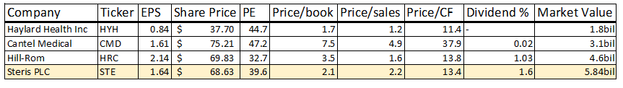
Steris has increased their dividend every year for the past ten years. In the last 3 years, dividends have been $0.82 per share, $0.90 per share, and $0.98 per share annually increasing each year by $0.08 each year.

Financial Analysis

Over the past few years, Steris Revenues have grown partly due to the acquisition of Synergy Health. Net income has gone down mostly due to restructuring costs. Please refer Figure 1 at the end of this analysis. Dividends have consistently gone up. Dividends are expected to reach $1.09 in 2017. This is a 10.71% increase over the previous year’s $0.98 annual dividend. Steris stock price more than doubled in the last 5 years. The price in 2012 was around $30 per share. 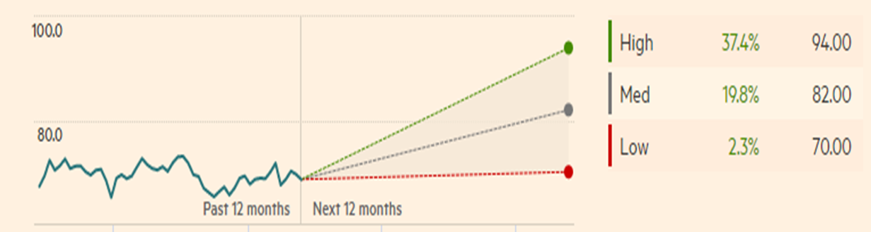Consensus earnings forecasts project future share prices to increase between 2.3% and 37.4% in the next 12 months.

Investment Risks

Steris is exposed to various investment risks. Steris could be negatively affected by adverse economic cycles if their customers have difficulty financing their purchases due to tight markets. Global and European economic conditions can also affect the company because many global customers are governmental entities or other entities that rely on healthcare systems or government funding. By doing business globally, Steris is also open to exchange rate fluctuation.

Recommendation

Our recommendation for Steris PLC is hold to buy for multiple reasons. Steris stock price has more than doubled in the past 5 years. They also have steady dividend growth. Finally, Steris has positive ratings from the analysist following them.

Figure 1
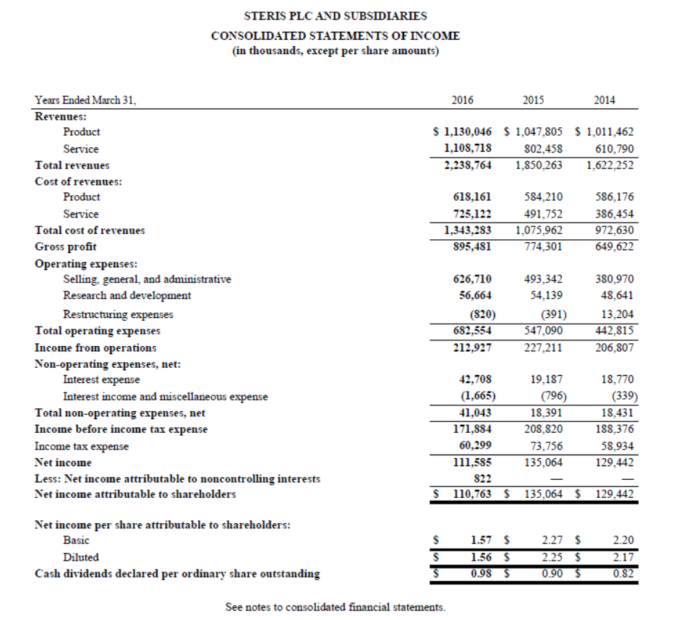
*This statement taken from Steris PLC 10k report.

