Lorraine Christianson
Xin Zhou

NeoPhotonics

Company Snapshot:
NeoPhotonics is traded on the New York Stock Exchange as NPTN. The company is part of the Information Technology sector and the semiconductor and semiconductor equipment industry. The stock was trading at $9.17 on Mar. 19 2017. There are 42.32 million shares outstanding with market capitalization of $388.11 M.

Major shareholders:
30.55% shares held by insider and 5% owners
57.5% of shares held by institutional & mutual fund owners

Top Institutional holders:
- Oak Management Corp 5,571,335 shares 13.16%
- Dimensional Fund Advisors LP 2,611,828 shares 6.17%
- Wellington Management Company,LLP 2,326,554 shares 5.50%
- AWM Investment Company, LLP 1,833,538 shares 4.33%
- Vanguard Group, Inc. 1,793,287 shares 4.24%

Direct Holders:
- Carano Bandel L (Managing Partner of Oak Investment team) 5,470,780 shares
- Jenks Timothy Storrs (President & CEO) 176,157 shares
- Sitler Benjamin Lee (Vice President of Global sale) 75,894 shares
- Abbe Charles J (Independent director) 59,431 shares
- Wupen Yuen (Vice President and General Manager) 21,908 shares

Our recommendation is to buy or hold stock in NeoPhotonics. The following analysis will explain our decision.

Business Description:
Understanding what Neophotonics does is a lot to comprehend. Basically, they use light and electricity to increase bandwidth. Other companies buy their products so that when they are running their internet sites, whether that be business or commercial sites, they can accurately handle high volumes of traffic. For example, if everyone was trying to stream a particular football game from the internet and the site hosting the game wasn’t properly prepared with the correct bandwidth capabilities the site would crash and no one would get to watch the game. If no one is able to watch the game then the company doesn’t make any money. This example is off topic but it will help readers to grasp the concept of bandwidth. A harder concept to grasp is how the company uses electricity and light to create these bandwidth capabilities. In simple terms, light can be reflected easily and quickly. The shape of light allows a vast amount of information to be transmitted off all of the different angles that light has. Using light is much quicker and more efficient that using electricity. Currently systems use both electricity and light to function. Eventually all light (optical) technology will probably replace electrical technology. NeoPhotonics research and development activities continue to push the performance leadership boundaries in high speed digital optics, hybrid optical integration, optoelectronics control and in signal processing.

NeoPhotonics has research and development facilities in Dongguan, Shenzhen and Wuhan, China, Ottawa, Canada, and Moscow, Russia. These facilities coordinate with the wafer fabrication facilities in San Jose and Fremont, California and in Tokyo, Japan. NeoPhotonics is a vertically integrated company. They use proprietary design tools and design-for-manufacturing techniques to align their design process. They are we are one of the highest volume Photonic Integrated Circuit, or PIC, manufacturers in the world and have the ability to expand their manufacturing capacity to meet market needs.

As with most technology companies, NeoPhotonics has a high product turnover ratio. It is unlikely that a product will last longer than 5 years before it is replaced with some new, better technology. Right now Neophotonics is selling various pluggable modules that support from 100G to 400G connections, the switches and drivers to support these modules, and lasers and other modules to allow them to run. They also have products that allow users to monitor their optical and electrical systems.

NeoPhotonics sells their products to the world’s leading network equipment and optical module companies. These customers serve the telecom market and also the datacenter market, represented by companies including Amazon, Facebook, Google and Microsoft. It is these companies that NeoPhotonics focuses their strategy and market position on due to their important positions in high speed and related communications networks markets.

Sales of NeoPhotonic products are made pursuant to purchase orders, often with short lead times. These purchase orders are typically made without deposits and may be subject to revision or cancellation. The quantities actually purchased by our customers, as well as the shipment schedules, are frequently revised to reflect changes in our customers’ needs.

Top Customers:
- Ciena Corporation,
- Cisco Systems, Inc.,
- HiSilicon Technologies, Ltd.,
- Huawei Technologies Co., Ltd. (collectively “Huawei”) and
- Nokia Corporation (formerly Alcatel-Lucent SA which was acquired by Nokia Corporation in January 2016).

Huawei and its affiliate HiSilicon Technologies, accounted for approximately 40% of the revenue in 2015 and 50% of the revenue in 2016. Ciena accounted for approximately 25% of the revenue in 2015 and 15% of the revenue in 2016.

NeoPhotonics is very dependent on these customers. A reduction of orders from any of these companies would have an impact on revenue.

Right now the 100G products are Neophotonics main source of revenue. As would be expected, their main expense is research and development. Sales and marketing, general and administrative, amortization of purchased intangible assets, acquisition-related costs, restructuring charges, and asset impairment charges are other major expense categories.

You may have noticed that one of NeoPhotonics major expense categories is, “acquisition-related costs”. In addition to developing its own technologies and products, NeoPhotonics has acquired 11 companies since the beginning of 2003, and they are looking to add more soon. These products have added key technologies and have had a major impact on revenue.

Management & Governance:

The board of directors of NeoPhotonic has adopted Corporate Governance Guidelines.
NeoPhotonics is currently combining the positions of Chief Executive Officer and chairman of the board of directors and thinking it is beneficial. Officer and Chairman is better positioned to act as a bridge between management and the board of directors, facilitating the regular flow of information. It helps to ensure that the board of directors and management act with a common purpose, provides a single, clear chain of command to execute our strategic initiatives and business plans.

NeoPhotonics have divided board of directors into three Committees, Audit Committee, Compensation Committee and Nominating and Corporate Governance Committee.

Audit Committee is responsible for selecting, hiring, supervising and evaluating the independent registered public accounting firm and reviewing and discussing with management and the accounting firm our annual audited and quarterly financial statements.
Compensation Committee is responsible for reviewing and approving the compensation of our directors, administering stock option plans, stock purchase plans, compensation plans and similar programs, identifying and developing internal employees with the potential to fill executive or management positions.

Corporate Governance Committee is responsible for assessing the performance of our management and our board of directors,identifying, reviewing, and evaluating candidates to serve and developing a set of corporate governance principles.

The following table illustrates the proportions of base salary, target variable bonus and equity awards in 2015:
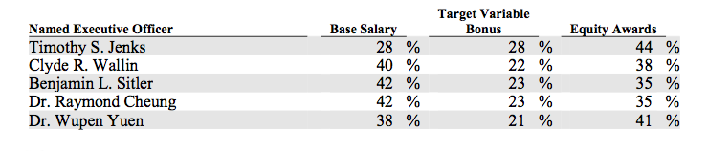
In October 2015, our Compensation Committee approved the grant of the following equity award to executives:
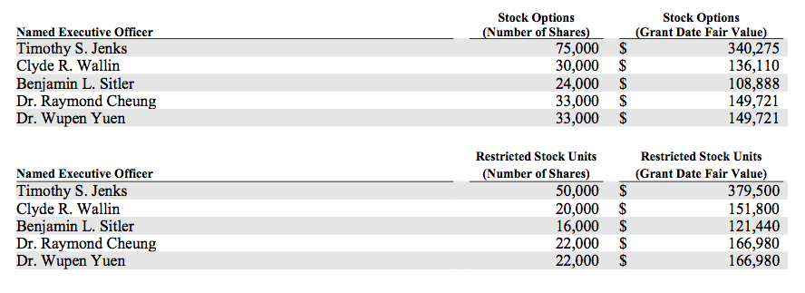
Industry Overview & Competitive Positioning:
The technology industry is highly competitive. Pressure is constantly put on companies to reduce prices resulting from increased competition, overcapacity, and the introduction of new products. While no single company competes with NeoPhotonics across all of their product areas, their competitors range from large international companies offering a wide range of products to smaller companies specializing in narrow markets.

According to NeoPhotonics the principal competitive factors in this market are:

- Ability to provide leading edge technologies for high speed communications
- Ability to design and manufacture high quality, reliable products, including customized solutions
- Breath of product solutions
- Price to performance characteristics
- Financial stability
- Ability to quickly and consistently produce in high volume and high quality
- Ability to meet customer’s specific requirements
- Ability to meet customers lead time demands
- Depth of relationships with and proximity to key customers globally

NeoPhotonics is competing favorably with respect to these factors.

NeoPhotonics competitors have greater name recognition and technical, financial and marketing resources. Many of their competitors have greater resources to develop products or pursue acquisitions, and more experience in developing or acquiring new products and technologies and in creating market awareness for these products and technologies. In addition, a number of NeoPhotonic’s competitors have the financial resources to offer competitive products at or below market pricing levels. This could prevent them from competing effectively and could adversely affect financial performance.

Top Competitors
Company | Estimated Revenue | Headcount | Stock Price
M/A-COM | $420.6M | 1,200 | $45.92
Oclaro | $341.3M | 1,200 | $8.88
Neophotonics | $339.4M | 2,300 | $ 9.72
Applied Optoelectronics | $189.9M | 2,500 | $49.23
Kaiam | $17.5M | 180 | Private Company

NeoPhotonics also faces competition from some of their customers, including Huawei and its affiliate, HiSilicon. This company has the ability to evaluate NeoPhotonics capabilities against their own capabilities. If they find that they can produce their own products to best suit their needs they have the ability to manufacture competitive products at a lower cost than NeoPhotonics would charge as a result of their higher levels of integration. As a result, these customers may purchase less of NeoPhotonic products and there would be additional pressure to lower NeoPhotonic selling prices.

Valuation and Financial Analysis:

Historically, the first quarter revenue is generally seasonally lower than the rest of the year. This is primarily due to lower capacity utilization during the holidays in China and the impact of price negotiations conducted at the end of each calendar year. This historical pattern is important in recognizing the typical annual distribution of revenue from quarter to quarter through the year. That said, it varies markedly year to year so should not be considered a reliable indicator of NeoPhotonics future revenue or financial performance.

Company | Estimated Revenue | Number of Shares | EPS (latest data)
M/A-COM | $420.6M | 350,266 | -$.02
Oclaro | $341.3M | 15,458,484 | $.17
Neophotonics | $339.4M | 1,642,012 | $.2
Applied Optoelectronics | $189.9M | 1,824,151 | $.95
Kaiam | $17.5M | Private Company

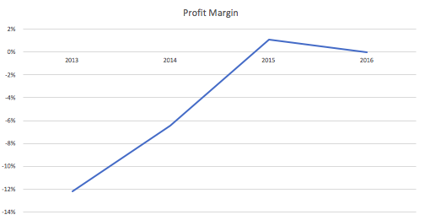
NPTN's profit margin has been consistent or even increasing over the past three years (Current year: -0.05%, Last year: 1.08%, Two years ago: -6.44%). It is a sign of good management and a healthy and competitive enterprise. NPTN's current profit margin is -0.05%, not in a strong situation. A true test of the quality of a company is that if they can sustain this up-trend of margin.
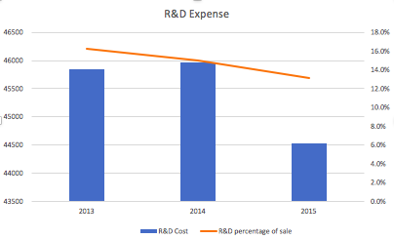
NeoPhotonics should be considered as high-tech company. Consistently investing in research and development similar with competitors is a good sign.

NeoPhotonic’s insiders should own at least 10% (they own 14.54% ) of the company's outstanding shares which is the minimum required. A high percentage typically indicates that the insiders are confident that the company will do well.

NPTN has either issued a significant amount of new shares over the past year or has been issuing more and more shares over the past five years. NPTN currently has 42.0 million shares outstanding. This is not a good sign. Generally when a small-cap company issues more stock, the existing stock becomes diluted and devalued by the market. Also, Neophotonics is little too liquid that it is difficult to remain relatively undiscovered by institutions.

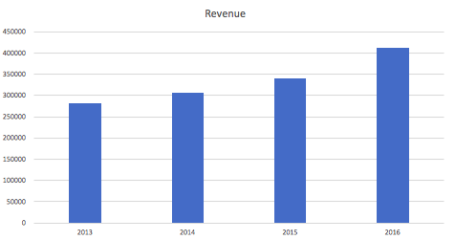
NPTN's sales is $411.4 million based on trailing 12 month sales. Sale of NPTN has been consistently grown over past four years (current year: $411.4M, 2015: $339.4M, 2014: $306.2M, 2013: $282.2M). Also cash flow from operating activities has been increased for three years (current year: $53.8M, 2015: $26.13M, 2014: $-0.45M). This is very positive sign of valuation of NeoPhotonics because we will be confident about growing and positive earning forecast and stock price.

Valuation summary:
Analysts expected one-year target stock price to be $10.71, true value of $11.77. At this time, NeoPhotonic is a little undervalued and analysts recommended to buy or hold the stock because of favorable fundamental factors of NeoPhotonic and forecasted constant growth in sale.

Investment Risks:
The Company operates in a dynamic industry and can be affected by a variety of factors. Any of the following areas could have a negative effect on the Company;
- The general state of the U.S., China and world economies
- The highly cyclical nature of the industries the Company serves
- The loss of any of a small number of its larger customers
- Ability to obtain additional financing
- Inability to meet certain debt covenants
- Fundamental changes in the technology underlying the Company’s products
- The hiring, training and retention of key employees
- Successful and timely completion of product design efforts
- New product design introductions by competitors
- The performance of their subsidiaries

Recommendation:
The investment recommendation for NeoPhotonics stock is to buy or hold under the assumption that the investor will pay close attention to developments within NeoPhotonics and the industry as a whole. Technology can be a hit or a miss, or both. Right now NeoPhotonics future is looking optimistic and it is a good investment. However, if anything were to change in the company or the industry NeoPhotonics could become a bad investment. NeoPhotonics has the potential to be a company that is high risk but offers a high reward.

