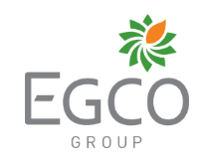
Sam Williams, Kendra Jensen, Connor Bendt, Caroline Shen, and Nick Thrune

FIN 422

Dr. Larry Schrenk

5.03.2019

Background
The Electricity Generating Public Company Limited (EGCO) is the first independent power producer in Thailand, established on May 12, 1992, by Electricity Generating Authority of Thailand (EGAT). In 1994, EGCO Group was transformed into a public company and then listed on the Stock Exchange of Thailand on January 16, 1995. As a holding company with its headquarters in Bangkok Thailand, EGCO Group’s main source of revenue is dividend income from subsidiaries and joint ventures in Thailand and across countries in Asia Pacific region including Lao PDR; Indonesia; Philippines; and Australia. The Company’s subsidiaries operate in either the power business with Power Purchase Agreement (PPA) or other related power generation and distribution businesses. As of 31 December 2018, there were 26 operating power plants across EGCO Group with a contracted capacity of approximately 4,260 MW equity. They have three projects under construction with an additional capacity of 544 MW, which is due to be operational between 2019 and 2022. The EGCO Group power plants presently generate electricity using several fuel sources such as natural gas, coal, biomass, hydro, solar, wind, and geothermal which partly enhance the country’s power security. The Mission of EGCO is:
1. To secure continuous growth in order to maximize shareholder’s value.
2. To offer a reliable power supply
3. To be a good corporate citizen, and be considerate to society and the environment. Thus, EGCO Group is greatly determined to conduct their business based on the principle of sustainable development. Apart from operating performance, the company cares about environmental protection and social developmental support.

Business Description
In addition to the power industry, EGCO also operates the power service provision business and the coal mine business. As for the power service provision business, EGCO holds 100% stocks in EGCO Engineering and Service Company Limited (ESCO) which provides operation, maintenance, engineering, and construction services to power plants, petrochemical plants, oil refineries, and other industries. Secondly, for the coal mine business, EGCO group indirectly holds 40% stock in PT Manambang Muara Enim (MME), which owns and operates an open-pit mine namely “Manambang Muara Enim”, located in Muara Enim, South Sumatra, Indonesia. This project has mineable coal reserves of 140 million tons. The sales volume of MME in 2016 was at 1.12 million tons.
Management & Governance
EGCO’s management team is an experienced and skilled management team. The average amount of experience is 30 years in the energy industry that EGCO is apart of. Before Jakgrich Pibulpairoj became the president of EGCO, he was the governor of business development at Electricity Generating Authority of Thailand. Jakgrich Pibulpairoj has been the president of EGCO since January of 2017. The CFO of EGCO is Danuja Simasathien and he has held that position since 2004. Jakgrich Pibulpraioj is seasoned with 15 years of experience in the industry. John Matthew Palumbo is the senior executive vice president of business development international and has held that position since February of 2016. John Matthew Palumbo has been in the energy industry since 1996 allowing him to provide experienced guidance to management. Senior executive vice president of strategy and asset management is Gumpanart Bumroonggit, he accepted his position in April of 2016. Bumroonggit served in multiple capacities in his previous jobs allowing him to provide well-rounded insight and expertise to the management team.

Industry Overview & Competitive Positioning
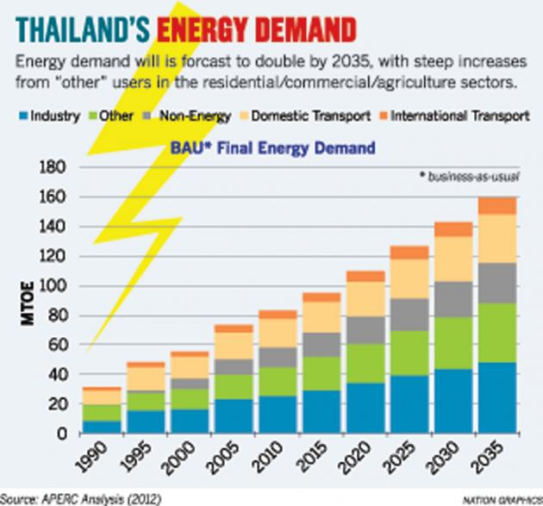
EGCO operates within the energy industry. The energy industry includes companies that provide energy and other various energy-related services. In 2013 Thailand consumed 75.2 Mtoe (million tonnes of oil equivalent) in 2013 with an increase of 2.6 Mtoe in 2014. The United States consumes roughly 100 times as much energy as Thailand, for comparison, but a large part of that difference is due to differences in size and population. The overall health of the economy is not a large factor for the energy industry because energy is seen as a necessity, not as a luxury. Demographic is irrelevant when it comes to energy because previously stated reasoning. The energy industry in Thailand is a competitive industry just like most countries, but EGCO is currently one of the dominating companies within that industry. Large companies like EGCO have advantages in this market due to high start-up costs. As far as Thailand’s energy generating, ninety percent of the energy produced is via conventional thermal. 37% of Thailand’s electricity is produced by independently owned producers, which is the category that EGCO resides in.

Growth Strategy
As stated previously, EGCO Group presently runs 27 operating power plants in 5 countries across the Asia Pacific region – Thailand, Lao PDR, Philippines, Indonesia, and Australia. There are 3 projects under construction presently that are scheduled to start commercial operations in 2019 and 2022. EGCO is continually investing in new growth opportunities especially in new countries, as they plan to diversify as much as possible and to continue growing into the future. EGCO Group aims to achieve its continuous sustainable growth by deploying three key strategies which have been continuously and earnestly implemented including:
- Ensuring maximum efficiency of existing power plants
- Managing projects under construction to be completed as plan and budget
- Seeking continuous investment opportunities.
Project selection criteria have been set to ensure quality investments and EGCO Group places a high priority in its overseas asset management, to best suit the business environment of the target countries including political and socio-economic policies and directions. As a holding company, EGCO Group’s main source of revenue will be from the dividend incomes from subsidiaries and joint ventures. The company mainly focuses on investment in the power business in both Thailand and the Asia Pacific region and also seeks investment opportunities in other related power business. EGCO is constantly expanding market share through developing and acquiring IPP projects in Thailand and the ASEAN region. EGCO invests in well-structured projects taking into consideration their areas of expertise and the projects’ economies of scale with an acceptable return and risk profile.

Valuation
According to our valuation, EGCO is showing promising returns in the near future based on their incorrect pricing. When looking into their absolute valuation, we are showing that the stock price should be at ฿403.37, but is currently only at ฿297.00. Our valuation strategy was estimated using the following 4 steps:
- Calculate the Free Cash Flows
- Calculate Terminal Free Cash Flow Value
- Discount the Free Cash Flows to the Present Value
- Sum them up and Divide by Number of Shares Outstanding
Step 1 is to calculate the free cash flows. The first free cash flow we need to calculate is the current free cash flow for the year 2018 using a levered free cash flow model. Next, we needed to determine the expected growth for the next several years until perpetuity. This was done by using the past 10 years of free cash flow and using those values to forecast free cash flows into the future. When we forecasted, we used a damped trend which decreased the growth of the free cash flow after the third year. Therefore, the free cash flow would grow at 16% per year for three years and decrease at 2% per year until 2027. Lastly, we need to determine a perpetuity free cash flow. In order to do this step, we cut off our free cash flow growth at 2027 when the free cash flow was growing at 4%. The current 10-year t-bond yield is currently at 2.53% which we will use as our discount rate and the projected growth of our company until perpetuity is 2%. Therefore, we calculated our terminal value by using the Gordon Growth Model and instead of using dividends we used cash flow. Next, we discount each free cash flow to the present value using the discount rate of 2.53%, sum all of the discounted free cash flows together and divide by the total number of shares outstanding. When we do this, we get an intrinsic value for our stock of ฿403.37. Since the current market value of EGCO is at ฿297.00, this would make the stock 35% undervalued.
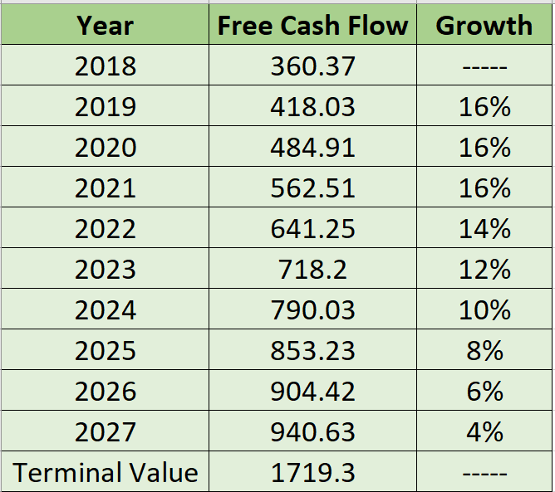

Currency Analysis
Since our company is based in Thailand, we felt that looking at the history of the Thai baht is necessary. The currency is stabilized and has a slight upward trend. In the past, the Thai Baht has been very volatile until the bank of Thailand implemented regulation in order to contain the volatility and in 2010, they removed this regulation because it was not needed since the currency was stabilized. We can infer that if there is any severe fluctuation in the currency the government will implement whatever is necessary to stabilize the currency. When looking at the other countries EGCO did business with, all the currencies were stable as well with the Philippine peso having slight volatility which should not be a concern in the long run.
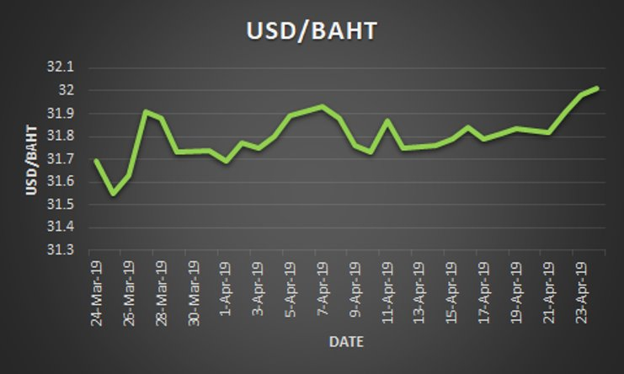
Ratio Analysis
The ratio analysis looked at several ratios which highlight the reason we believe EGCO is undervalued. The ratios we will look at include the dividends per share, the Price to Earnings and the Return on Equity. The dividend per share chart shows that from 2013-2016, EGCO paid a consistently growing dividend and in 2017 the decreased their dividend in order to invest in growth opportunities in 2018. 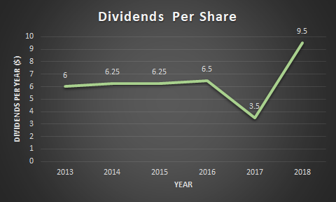

The P/E graph below shows that in 2015 the Price to Earnings ratio peaked in this year. During this same year, the energy industry also peaked, and the entire industry had a lack of interest from investors. During this time the Stock of EGCO remained stagnant and did not increase due to the lack of interest in the energy industry as a whole. Since the company was investing in overseas growth opportunities and growing their earnings compared to their price, their P/E ratio was decreasing and we believed that since the downward trend is decreasing the P/E ratio, the stock is worth buying since EGCO was able to almost triple its dividends in 2018 and the growth opportunities of EGCO are paying off to its investors.

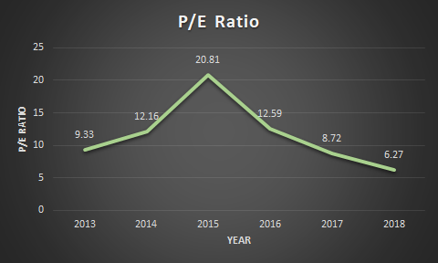
The last ratio we wanted to show to illustrate our point about our company's investment in growth opportunities. As we can see in the graph of the ROE, EGCO has been able to increase their ROE since 2015. EGCO has since an increase in ROE because it has invested in overseas operations and expanded its company to the global market. This has allowed the company to build plants and sell energy in six major countries which include Australia, Philippines, South Korea, Laos, Indonesia, and Thailand. Clearly, this company is still able to expand into the global market and continue a high return on equity which makes EGCO a good growth company to invest in.
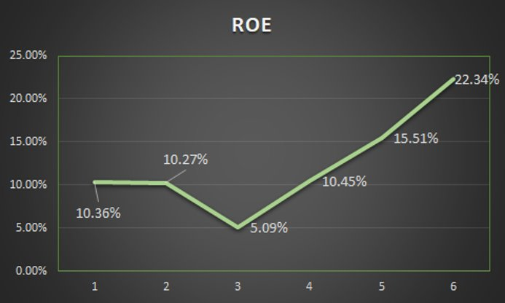

Investment Risks
Being that EGCO operates within the energy industry they do not have nearly any industry risk, consumers will need energy for the next 100, 200 years and so on. Thailand’s energy demand is forecasted to grow double what it is now by 2035, this creates a large opportunity for EGCO. EGCO does face some risk when expanding into these new territories, but EGCO has implemented strategies within their organization to enable all expansions to have benchmarked scheduling and budgeting metrics to make sure all expansions are on track for time of completion and are within the allocated budget. EGCO is currently exploring many new expansion opportunities to gain more market share and increase overall operating efficiency. Obviously with these expansions comes risk as they may run into different operating regulations between different countries and may result in higher costs than expected.

Investment Summary
Since EGCO was founded they have been paving the way in Thailand and the other countries they are expanding into by being an independent power producer. The company is led by a very experienced management team that has been in the energy business on average over 30 years. EGCO currently has 3 large projects to be completed by 2022 which will allow the company to grow future revenues along with the stock price. Operating in such an industry as energy is beneficial because it will always be needed, and historically the energy stocks show similar stability. A significant portion of the success of EGCO comes from the effective growth and expansion strategies their executive teams have put into place. EGCO also gets their revenues from many different sources of power and investments holding a very diverse and effective business model.

After analyzing EGCO based on their financials, executive board of directors, and their business model we have determined that EGCO is currently underpriced and should be considered a profitable buy.

Sources
https://www.egco.com/en
https://www.egco.com/en/corporate-profile-senior-management

