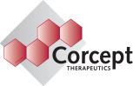

**Company Evaluation**

**James Edstrom**

**Taylor Field**

**Micah Stark**

**Basic Information**

c(CORT) is a company within the Health Care Sector and Pharmaceuticals Industry publically traded on the Nasdaq since 2004 when its IPO price was $12. Currently, shares are trading for $9.64/share which is undervaluing Corcept Therapeutics since their primary drug, Korlym, has yet to reach full potential in its primary market and has potential to be effective in other uses as well. The target stock price is $18.43 which leaves Corcept Therapeutics undervalued by $8.87/share. The market will make pricing adjustments more efficiently once Corcept Therapeutics’ revenues over the next couple of years continue to see strong growth as Korlym is more widely used for the treatment of Cushing’s Syndrome and the drug is approved to be used in combination for the treatment of the most difficult types of Cancer. At the current stock price, Corcept Therapeutics has a market capitalization of $1.08 Billion.

|  |  |
| --- | --- |
| **Institutional Investors** | **Share of Market Capitalizaiton Owned** |
| *All Institutional Investors* | *41.3%* |
| Federated Investors, Inc. | 12.5% |
| Ingalls & Snyder | 7.35% |
| The Vanguard Group | 3.05% |
| BlackRock Fund Advisors | 2.97% |
| BlackRock Institutional Trust Company | 1.93% |

Corcept Therapeutics operates in the Health Care Sector and specifically the Pharmaceutical’s Industry. Corcept Therapeutics’ primary drug is Korlym which accounts for all of their revenues since Korlym was approved by the FDA in 2012 for the treatment of Cushing’s Syndrome. Since Corcept Therapeutics is only just beginning to fully market the drug to potential users, the revenues and number of users will continue to grow steadily for the next couple of years.

Currently, 41.3% of Corcept Therapeutics’ shares are held by institutional and Mutual

Fund Owners including (in order of shares owned): Federated Investors, Inc. (12.5%), Ingalls & Snyder (7.35%), The Vanguard Group (3.05%), BlackRock Fund Advisors (2.97%), BlackRock Institutional Trust Company (1.93%).

**Business Description**

Corcept Therapeutics primarily sells Korlym directly to patient through Dohmen, a specialty pharmacy. Korlym is the only pharmaceutical that is current generating revenue for Corcept Therapeutics. Korlym is a 300mg modified version of mifepristone, taken once-daily orally, that blocks cortisol, a hormone in the body. Korlym helps to control the side effects associated with excess cortisol. Side effects associated with excess cortisol include: obesity in the body’s core, a round face, easily bruised skin, muscle weakness, thin bones, depression and stomach ulcers. Korlym is only to be prescribed and used by patients suffering from both Cushing’s Syndrome and Type II Diabetes.

Corcept Therapeutics major costs include research and development which accounts for 26% of gross revenues from Korlym. Corcept has several potential treatments in research and development such as a combination of Korlym and Abraxane for the treatment of metastatic triple-negative breast cancer. Triple-negative breast cancer is a breast cancer that is not fueled by the estrogen receptor, progesterone receptor or Her2/neu. Triple-negative breast cancer is the most difficult breast cancer to treat and often requires a combination of several different treatments to attempt to combat. However, Corcept Therapeutics has seen initial positive signs from the combination of Korlym and Eribulin and will likely continue testing with clinical trials for the next couple of years. Corcept Therapeutics is also in clinical trials for a combination of Korlym and an androgen deprivation agent enzalutamide for the treatment of triple-negative breast cancer. There is a definite upside if this treatment combination is found to be effective in clinical trials.

Corcept Therapeutics main cost is found in selling the selling of Korlym which accounts for 54% of gross revenues. Korlym has yet to fully penetrate the applicable market of patients with Cushing’s Syndrome and type 2 diabetes. However, as Corcept Therapeutics begins to process positive cash flows and a positive, comprehensive income; Corcept will be able to further fund the marketing of Korlym. Q1 2017 was the first quarter that Corcept Therapeutics produced positive earnings and ended with a net earning per share of $.04 exceeding expectations of $.03. The stock performance has been very positive over the last year with a price change of 100.00% as shown below. 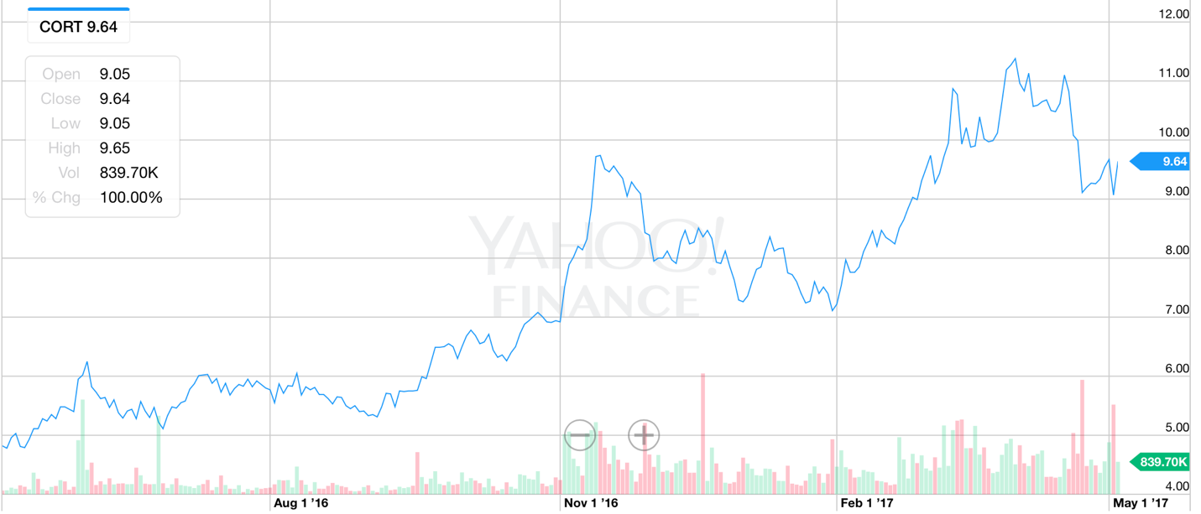

**Management & Governance**

|  |  |  |  |
| --- | --- | --- | --- |
| **Name** | **Position** | **Salary** | **Equity Compensation** |
| Joseph Belanoff | CEO | $1,015,000 | $1,382,390 |
| Robert Fishman | CMO | $451,363 | $234,067 |
| Gary Robb | CFO | $520,685 | $377,015 |

Corcept Therapeutics management structure is as follows; Dr. Joseph Belanoff, as co-founder, serves as the Chief Executive Officer, President and Director. Dr. Belanoff has served as CEO since the company’s inception in 1999 and his compensation includes a salary of $1,015,000 along with equity options worth an additional $1,382,390. The Chief Medical Officer, Robert Fishman, joined Corcept Therapeutics in

September of 2015. Robert Fishman has worked in the pharmaceutical industry for 19 years and helped bring Esbriet to market from 2012 to 2015. Robert Fishman’s compensation includes a salary of $451,363 and equity options worth $234.067. The Chief Financial Officer is Gary Robb who assumed his role in September of 2011. Prior to Corcept Therapeutics, Gary Robb served as the Vice President of Operations for Fitness Anywhere, Inc., and his compensation includes a salary of $520,685 along with equity options of $377,015.

Corcept Therapeutics’ Board of Directors consists of James Wilson who has served as the Chairman of the Board since the company began in 1999. As previously referenced, Joseph Belanoff, the CEO, also serves on the board. Other board members includes one other member since the company is founding, and several venture capitalists.

**Industry Overview and Competitive Positioning**

Corcept currently is the only drug company that has patents on Korlym; however, other drug companies like Novartis’s Signifor would be the closest competitor for a like drug like Korlym in curing Cushing disease. More will be discussed about Novartis’s Signifor on the section investment risk.

**Valuation Model**

For the valuation model, Corcept Therapeutics is expecting more people will be using this drug for curing Cushing Syndrome. Last year was Corcept Therapeutics first year for positive net income. Corcept Therapeutics has never paid any dividends throughout their history of being a publicly traded company. Corcept Therapeutics focuses on one drug so the valuation came from the amount of peopling needing Korlym in the financial model. Cushing’s disease is very rare and that creates more of a challenge when evaluating the firm’s current stock value. In Corcept Therapeutics’ previous years growth has occurred very fast since being the FDA approved the drug Korlym in 2012. The FDA’s recent approval has made it difficult to evaluate the next 10 years of growth. The best way to decide on growth would be increasing at a decreasing rate for the customers needing the drug.

**Financial Analysis**

*10 Year Forecast in Millions except EPS*

|  |  |  |  |  |  |  |  |  |  |  |  |
| --- | --- | --- | --- | --- | --- | --- | --- | --- | --- | --- | --- |
| Year | **2016** | **2017** | **2018** | **2019** | **2020** | **2021** | **2022** | **2023** | **2024** | **2025** | **2026** |
| Revenue Growth % |  | 47% | 36% | 29% | 24% | 20% | 17% | 15% | 13% | 12% | 11% |
| **Revenue** | **81** | **119** | **162** | **209** | **259** | **312** | **366** | **421** | **478** | **535** | **593** |
| Cost of Sales | 2 | 3 | 4 | 5 | 7 | 8 | 9 | 11 | 12 | 14 | 15 |
| R&D | 24 | 36 | 49 | 63 | 78 | 93 | 110 | 126 | 96 | 107 | 119 |
| SG&A | 45 | 54 | 73 | 94 | 117 | 140 | 165 | 189 | 215 | 241 | 267 |
| **Total Operating Expenses** | **71** | **92** | **126** | **162** | **201** | **242** | **284** | **327** | **323** | **362** | **401** |
| Income (Loss) from Operations | 10 | 27 | 36 | 47 | 58 | 70 | 82 | 94 | 155 | 173 | 192 |
| Interest and other Expense | (2) | (5) | (6) | (8) | (10) | (7) | (8) | (9) | (15) | (17) | (17) |
| **Net Income** | **8** | **22** | **30** | **39** | **48** | **63** | **74** | **85** | **139** | **156** | **175** |
| EPS | 0.07 | 0.19 | 0.25 | 0.33 | 0.40 | 0.51 | 0.60 | 0.68 | 1.11 | 1.23 | 1.36 |
| Shares | 116 | 117 | 118 | 120 | 121 | 122 | 123 | 125 | 126 | 127 | 128 |

**Sensitivity Analysis**

The sensitivity analysis would be just putting different numbers in the equation in order to find out the new Net Present Value for the current share price. For each of these equations we increased and decreased at separate times to find a different per share price. The sensitivity analysis does show that there is a good chance of growth for the company. The sensitivity analysis gives a better prospective of the company increasing or decreasing the company’s beta or the cost of capital by 10%. Lastly something else that can sporadically change the company’s overall value when other companies being able to make a drug like Korlym but not copying the Corcept patents.

|  |  |  |
| --- | --- | --- |
| Sensitivity Analysis | | Share Price |
| **Beta** | **1.36** | **$ 14.03** |
| Increased by 10% | 1.50 | $ 11.75 |
| Decreased by 10% | 1.24 | $ 17.27 |
| **Cost of equity** | **12.31%** | $ 14.03 |
| Increased by 10% | 13.54% | $ 18.09 |
| Decreased by 10% | 10.89% | $ 10.83 |

**Investment Risk**

One of the biggest risks for Corcept Therapeutics is the heavy reliance on the drug Korylm. If people start having negative side effects after a few years, the FDA would get involved in ending the production of the drug. If Corcept Therapeutics is unable to increase revenue from the sale of Korlym to the levels investors expect, or experience significant delays in doing so, CORT will likely decline. Novartis’s Signifor is the main competitor since both drugs treat almost the exact same disease. Another risk for Corcept is if physicians stop prescribing the drug for an unforeseen reason. Physicians will prescribe Korlym only if they determine that it is preferable to other treatments, even if those products are not approved for Cushing syndrome. Cushing syndrome is a very rare disease making most physicians inexperienced in the care of patients with the illness. This unfamiliarity may make it difficult to persuade them to prescribe Korlym, even with clinical trial results that show it is a compelling treatment. Lastly, some physicians may maintain their preference for more familiar, long-standing off-label treatments for Cushing syndrome. Other contributing factors contributing in Corcept Therapeutics’ riskiness are alternative methods, such as surgery and radiation therapy. Even though Corcept Therapeutics holds the patent for Korlym, the drug still needs to be produced and prescribed for Corcept to generate revenue.

Corcept received the Orphan Drug designation meaning “pharmaceutical that remains commercially undeveloped owing to limited potential for profitability” in the United States. Even after an Orphan drug is approved for its orphan indication, the FDA can subsequently approve a different drug for the same condition if it concludes that the later drug is safer, more effective or makes a major contribution to patient care.

**Conclusion**

Calculating the percentage growth rate over the next 10 years was the biggest factor in figuring out what the current stock price should be at from the model. Morningstar, finviz, and the CBOE all give CORT a higher expected value than what the stock trades for currently. The shares outstanding are 112 million and 6.79% are being shorted giving the general perspective that investors are optimistic for this company in the next few years.

