Columbia Sportswear

Beau Mikel, Nick Taylor, Taylor McMillin, and Nina Quist
FIN 422
Dr. Schrenk

Background on Columbia
Columbia Sportswear Company was founded by Paul Lamfrom and his wife Marie. Living in Augsburg, Bavaria, Paul owned the largest shirt, sock, and underwear company in the country. In late 1937, the family fled from Nazi Germany and immediately bought a hat distributorship in Portland, Oregon called Rosenfeld Hat Company. The Lamfrom’s changed the company name to Columbia Hat Company shortly after acquiring the business. In 1948, Paul’s second daughter, Gert, married Neal Boyle. The business grew slowly but steadily. In order for the firm to enter other market segments, they again changed the name to Columbia Sportswear Company in 1960. Suddenly in 1964, Paul Lamfrom died from a heart attack leaving the business to son-in-law, Neal Boyle. Then in 1970, Neal died from a heart attack. Gert and her son Tim Boyle, at the time a University of Oregon senior, took over the operations of Columbia Sportswear, rescuing it from near bankruptcy.
Columbia Sportswear’s main competitors are VF Corporation, Patagonia, and Nike to name a few. VF Corporation consists of companies such as North Face, a major outdoor winter clothing company, and Timberland, a boot manufacturer. Patagonia is a private company that also specializes in making clothing for outdoor use. Columbia Sportswear has four main subsidiaries Sorel, Mountain Hardwear, Montrail and prAna, these will be touched on more in the upcoming sections.

Subsidiaries
As stated previously, Columbia has three major subsidiaries which are Sorel, Mountain Hardwear, and prAna. Their first major acquisition in 2000 was Sorel. Sorel is an Ontario based brand the specializes in lifestyle footwear. As far as their contribution to Columbia's sales as a whole they have the highest average amongst their other subsidiaries at around eight to nine percent. To add, Mountain Hardwear is another one of Columbia's subsidiaries which was purchased in 2003. Mountain Hardwear is a California based company that focuses on high-tech outdoor clothing, backpacks, and other outdoor accessories. Moreover, Mountain Hardwear trails behind Sorel in percent of sales at around four to six percent within the past 3 years. Lastly, prAna is the most recent of Columbia's acquisitions and was purchased in 2014. prAna is a clothing company that is headquartered in California and focuses on making versatile, stylish, and sustainable clothing that you can wear during every activity. To add, prAna makes up the smallest portion of Columbia's total sales at around three to five percent. This is most likely because of their recent acquisition by Columbia. I am sure that within the next few years their percentages will increase. Overall, Columbia makes up for over eighty percent of total sales of the company while Sorel, Mountain Hardwear, and prAna make up for the other twenty percent. I am sure that within the next few years Columbia will acquire more companies but for now they are doing very well for themselves and making smart investment decisions.

Financials to the Firm
In more recent news, the company reached a new high in sales in 2016, topping off at $2.4 Billion. The company today has a little over six thousand employees and operates in two different categories. They have an apparel, accessories, and equipment category which makes up roughly 80 percent of the business and a footwear category that makes up for the other 20 percent.
Next we would like to cover a little bit of the firm’s financials. We’ll take a look sales and net income from years 2013 to 2016. Over the last four years, Columbia Sportswear has had a slow but steady increase in sales. In 2013, sales recorded for the company were $1.68 Billion. In 2014, sales made a 25% increase from the previous year to $2.1 Billion, then the company recorded $2.33 Billion in sales in 2015 and $2.4 Billion in 2016. From 2013 to 2016, Columbia Sportswear noticed an average of nearly 13% growth in the firm’s overall sales. Over the same four years the firm noticed some considerable growth in net income, averaging 27.5% increase year to year. In the year 2013, Columbia Sportswear generated $94.34 Million, followed by $137.17 Million in 2014, $174.33 Million in 2015, and finally $191.89 Million in 2016.

Stock Performance
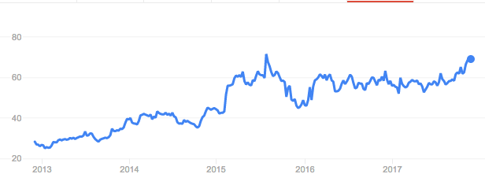
When examining the stock of Columbia Sportswear, we first started with analyzing the five year performance of the stock. Beginning in 2013 the stock was bouncing between $25 and $30. Since then they have seen a tremendous increase. From 2013 to 2015, the stock price increased from $30 to $45.This was due to the revenue push of existing brands such as Mountain Hardwear, Sorel, and the recent acquisition prAna. Starting in 2015, footwear for Columbia increased by 43% year over year. This was driven by a 40% jump in sales coming from the Sorel winter boots line. Between 2013 to 2015, Columbia was constantly showing new highs across the company. In July of 2015 Columbia hit an all-time high of $71.54. Although the company was showing stable growth, the stock price did start to decline from July 2015 to December 2015. The cause of this was aimed at the dependence of cold weather products coming from Columbia. The stock price does vary from year to year depending on the winter season. With the help of the subsidiaries, Columbia has recently been trying to take that dependence on those products away. Starting in January of 2016 the company’s stock has been gradually increasing, today hitting around $70.
After taking a look at Columbia Sportswear and the performance over the past five years we continued to dig deeper and proceeded to analyze a few of their competitors. The first competitor we have listed is VF Corporation, or VF Corp for short, is shown in the red. VF Corp is a large company with many popular brands such as Vans, The North Face, Timberland, Wrangler, and Lee. Looking at the past five years, this company has had its share of ups and downs. In 2013 they were trading at about $40, and they continued to increase until 2015 where the start of a consistent decrease that would last for the next two years can be seen. Since the beginning of 2017 the stock has shown an increase, starting this year with $50 and now reaching $75. The graph below shows that VF Corp has not been a stable company and would not be the best option to invest in. The next competitor we looked at was Under Armour, shown in the graph as the green line. This company has faced a number of challenges in the last few years. Under Armour had a stock price of just over $10 in 2013, they did have an upward trend until 2015 and hitting just over $30. They stayed level with trading around $30 for the year of 2015 and then started to decrease that following year. Today Under Armour has a stock price of $13. This company has seen a decline in sales mainly because of stronger competitors such as Columbia and Nike, and also a decline in North American sales which is their largest market. Finally, we took a look at Lululemon Athletica, shown in the purple. This company has had a high stock value compared to their competitors, but has had troubles with consistency. In 2013 Lululemon was trading at about $72. For the following three years we see a slow down fall. This is due to the reputation of some of their yoga and athletic wear. In 2013 they had a massive recall on black yoga pants that affected one if five pairs of pants and caused a lawsuit which greatly affected their company and coming profits. In 2016 the company did start to show a steady increase for the whole year, reaching a stock price of $68. The increase did slow down and for 2017 the stock price has been slowing going back down. Comparing the stock price over the past five years with Columbia Sportswear, VF Corp, Under Armor, and Lululemon we can easily see that Columbia has had a steady increase in growth and will continue to rise above its competitors.
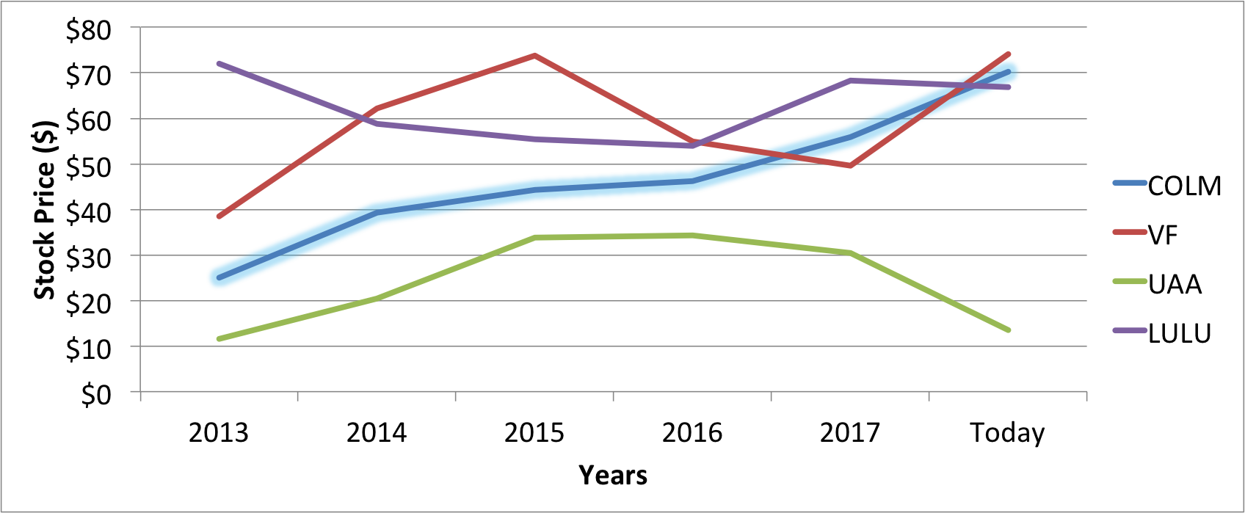

Growth
Columbia Sportswear is growing in a few ways. In January of 2016, Columbia was revealed to be the first official outdoor apparel partner for the Manchester United Football Club. The partnership exhibits the interest in the firm’s excellent and inventive outdoor apparel. As part of the partnership, Columbia has composed and constructed dual branded outerwear for outdoor ventures, incorporating hiking, climbing, mountaineering, along with water and snow activities. The Manchester United Collection has a variety of items for sale, ranging from $30 to $250, all displaying both Columbia’s logo and the Manchester United logo.
In May of 2017 Columbia Sportswear became the official outfitter of the United Kingdom National Parks Ranger and Staff. In the five year partnership, Columbia will clothe 2,000 staff members, which contains 300 rangers. The UK National Parks said about the clothes that will be provided, “Columbia will outfit National Park rangers and staff with several performance pieces, including the OutDryTM Extreme ECO Jacket. The ultimate sustainable waterproof breathable solution for extreme conditions, the OutDry Extreme Jacket is sustainably manufactured without PFCs (Perflourinated compounds)². The jacket’s design represents a sea-change in the development of performance rainwear, and signifies an important environmental advance.”
Another area for potential growth is through their partnership with the U.S. Freestyle Ski Team. For the next winter olympics until 2022, the U.S. Freestyle Ski Teams will be wearing uniforms produced by Columbia Sportswear. With the millions who watch the olympics every four years, the firm is sure to bring in sales as a result of people seeing how durable their clothing can be.
With all of the reasons mentioned above, Columbia Sportswear will most likely continue to grow over the years. They have made smart partnerships that will result in people seeing their products on a daily basis in different conditions.

Recommendation
As was shown in the stock performance section, the firm has a stable growth compared to both itself over time, and to their competitors. The overall sales to the firm has increased from $1.68 Billion in 2013 to $2.38 Billion in 2016. Their overall net income has also increased from $94.34 Million in 2013 to $191.89 Million in 2016. Over those five years this results in an average sales increase of 13% per year, and an average net income increase of 27.5% per year. Columbia’s own brand makes up the majority of the firm’s overall sales as compared with their subsidiaries. These trends are most likely to continue since the firm has entered into smart partnerships that allow many people around the world to see the conditions their products can endure, as mentioned in the growth section. Due to all of these factors, our recommendation is to buy more.

Sources
https://www.columbia.com/About-Us_Press-Center-Release_2016_01_22.html
http://www.nationalparks.gov.uk/about-us/news/press-releases/columbia-partnership
https://www.columbia.com/Athletes_US-Freestyle-Ski-Team.html
http://atheistjewingermany.blogspot.com/2009/02/lamfroms-from-augsburg-bavaria-founders.html
https://www.fool.com/investing/general/2015/02/13/why-shares-of-columbia-sportswear-company-soared-t.aspx
http://money.cnn.com/2014/06/12/investing/lululemon-stock-drop/index.html
http://www.prana.com/about-us/who-we-are.html
https://www.mountainhardwear.com/History.html

