The Children’s Place

Equity Research Report
By: Mitchell Johnson & Chelsi Nahrgang

Basic Information
The Children’s Place is the largest children’s specialty apparel retailer in America. The firm designs, manufactures, sells, and licenses fashionable, high-quality merchandise at value prices. The Children’s Place has 1,039 stores across the United States, Canada, and Puerto Rico, with a significant online presence online with their website www.childrensplace.com. The firm also has 150 international points of distribution open and operated by its 6 franchise partners in 17 countries. The Children’s Place stock trades primarily on the NASDAQ stock exchange under the ticker symbol PLCE. The current stock price is $113.55, and the firm has a market capitalization of $1.9 Billion. The Children’s Place has a group of major investors who own approximately 37.42% of shares. The largest Investor is The Vanguard Group, Inc which owns about 13.31% of shares with a total investment of $269,403,701.95. The second largest is BlackRock, Inc which owns 12.60% of shares with a total investment of $255,602,298.65. The third largest investor is Royce & Associates, which owns 6.08% of shared with a total investment of $122,948,026.30. The last major investor is Dimensional Fund Advisors LP, which owns 5.43% of shares with a total Investment of $109,824,794.05.
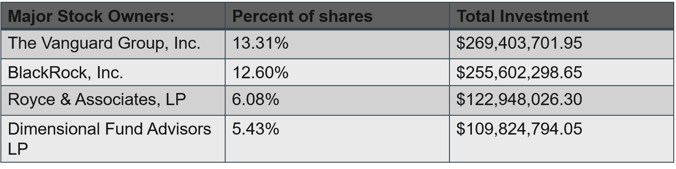

Competitive Environment
The Children’s Place stock price increased 45.6% during their fiscal 2016 year, and were in the 94th percentile of their peer group. The firm significantly outperformed their competitors during this time,
with many having negative growth.
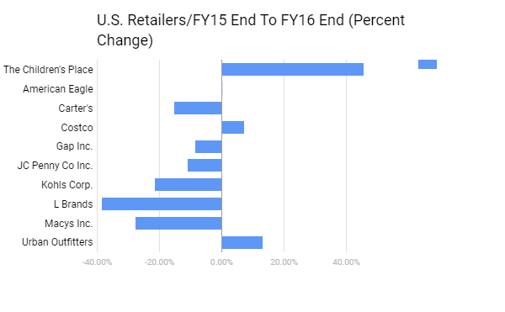
Although this was strong performance for the year, it does not show a long-term trend. It is important to analyze data over a longer period of time because one year could be an extreme in either direction and this would not lead to an accurate representation of the firm. The Children’s Place stock growth also strongly outperformed these competitors over a 5-year period, which is a better indication of its growth trend. The firm had about 140% in price growth over this time, which was over two times larger than its closest competitor. The bold blue line on the graph below represents The Children’s Place.
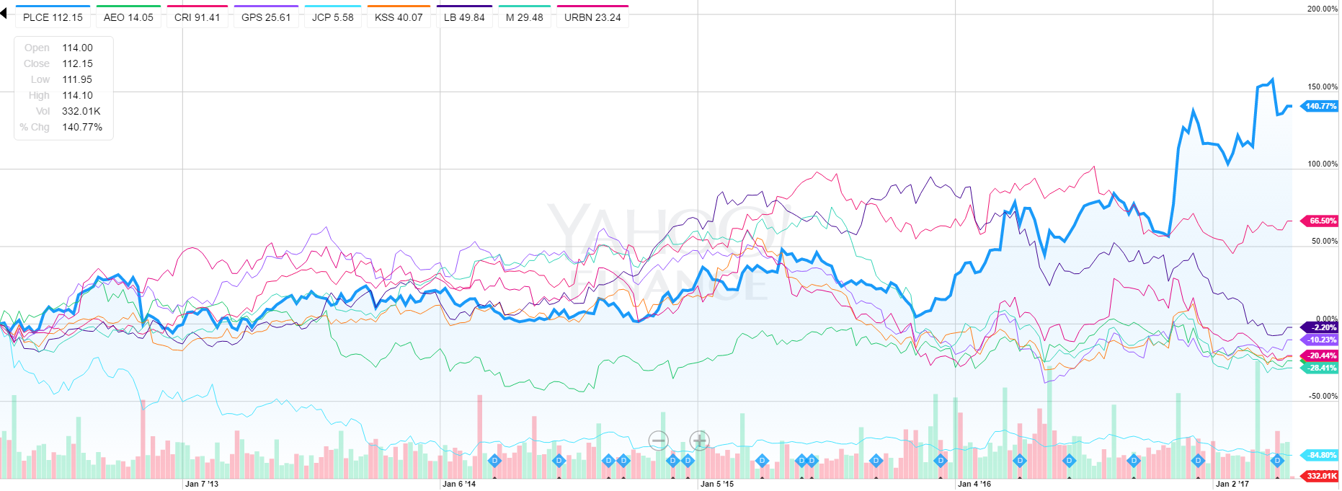

Return of Capital
The Children’s Place had strong financials over its 2016 fiscal year. The company paid $15 million in dividends over 2016 and is expecting an annual dividend increase of 100% from $.80 to $1.60 moving into 2017. This expected dividend growth is a sign that management has a positive feeling about it financials moving forward. The Children’s Place returned 83% of cash from operations in 2016, and repurchased over $150 million shares in 2016 with a total of $750 million in repurchases since 2009.
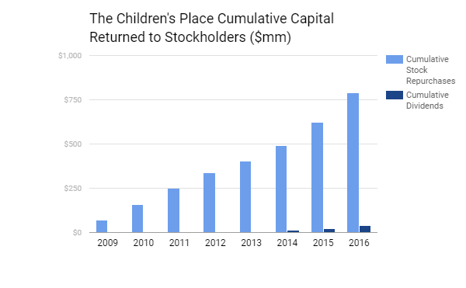
The company also reported strong return measures over fiscal 2016. The firms ROC, ROE, and ROA were all in the top 75 percentile of their peer group. Although this is strong performance, it must be taken with consideration since this data is coming from their own accounting data.

Consensus Earnings Forecast
The Children’s Place has a very strong analyst forecast. At the time of analysis, the stock price was at about $108. The forecasted 12-month price projection has a high price at $144 (32.4% increase), a median price of $132.50 (21.8% increase), and low price of $105 (3.4% loss). The current stock price is at approximately $113, which shows that analyst have been correct about its strong growth potential so far. Of the 11 analysts covering the firm, 6 have a buy rating, and 5 have a hold rating.
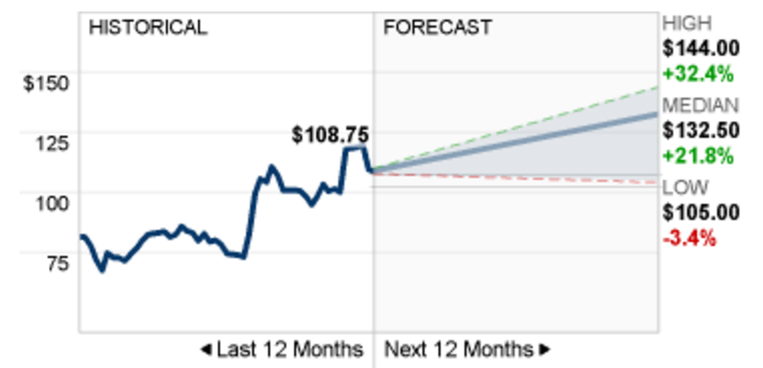
Sales Strategy
The Children’s Place uses multiple avenues in their sales strategy. The company uses the benefits of branding. They also employ significant sales often of up to 60% off. These sales allow for them to remain competitive with their pricing while not appearing cheap to the consumer. Coupons for their online store are easily found through a search engine or even directly through their website. The Children’s place also has a rewards point program. The rewards program equates to 5% back toward future purchases. JC Penney, a competitor of The Children’s Place, uses similar business strategies. Through these strategies, The Children’s Place has achieved a way to keep their customers coming back.
Valuation and Peer Comparison
As seen in the chart in the earlier section of competitive environment, The Children’s Place has far exceeded its competitors in regards to percent increase in stock price. In the last year, theirs stock price has gone up 62% over the last year from $71.25 one year ago to date. The Children’s Place has a P/E ratio of 20.88 compared to the industry average of 18.66. The company has EPS of $5.44. That is considerably better than JC Penney and Kohl’s who have ($0.04) and $3.13 EPS respectively. The Children’s Place saw a rapid spike in their share price in November 2016 when they beat their earnings forecast. Their stock price went from the mid-70s to over $100 per share. Recently, the company saw another spike in share price when they announced they were going to buy back more shares.
Financial Analysis
The Children’s Place offers a dividend going in to their fiscal year 2017 of $1.60 per share. This is a 100% increase over the previous year. The Children’s Place has increased their dividends each year since they started offering dividends in 2014. The first year they offered dividends, their dividend payout was $0.53 per share. Since then, dividends have increased to $0.60 per share and $0.80 per share each year respectively. Increase in dividends shows good signs for investors. While the company’s net sales only increased by $59,539 (3.4%) from 2015 to 2016, their net income increased by $44,452 (76%) in the same time frame. The drastic increase in net income was due to cost reduction in the following areas: cost of sales; selling, general and administrative expenses; and interest expense. These cost reductions increased the EPS to $5.40 from $2.80 the previous year.

Investment Risks
It is important to note investment risks. Having buying operations and distribution centers worldwide leaves The Children’s Place open to risks associated with currency exchange rates. The Children’s Place also deals with risks associated with generating sufficient cash flow. Factors that could impact The Children’s Place’s cash flow include: seasonal fluctuations and timing of inventory purchases, vendor/supplier terms and conditions, and overall economic conditions. Other risks include pressure on margins as a result of the competitive market and changes in federal, state or local law or tax codes.

Investment Recommendation
We give The Children’s Place a Buy recommendation for multiple reasons. The company has strong dividend growth. And, The Children’s Place has strong analyst recommendations. The median price forecast 12 months from now is $132.50, a 16.7% increase over the current price.

