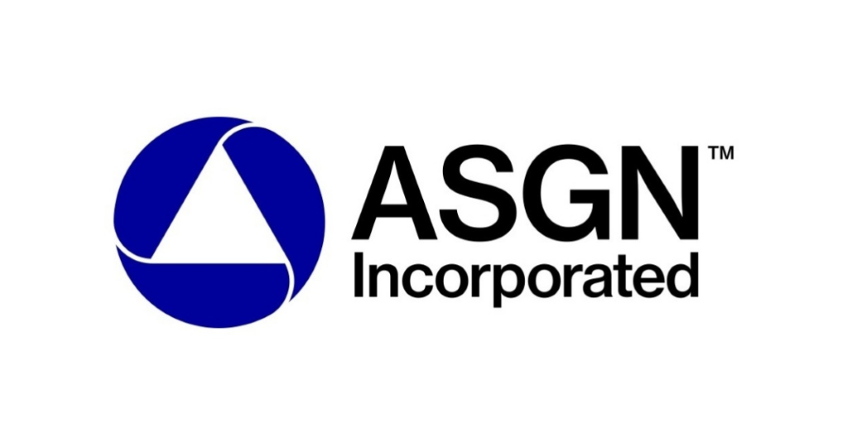

ASGN Incorporated
----------------------------
Financial Report
2019

Eli Casey, Hunter Drake, Caleb Wagner, McKenzie Meyers, & Coco Wiencek

Company Overview:
ASGN is one of the several companies on the Russell 2000. This is a great company to invest in for several reasons that we will cover in this report. They were established in 1985 and went public in 1992. A little background as to what this company does is it provides information technology and professional services in several different sectors including: digital, creative, healthcare technology, and government, among others. They are extremely diverse and provide services to many different industries. This is extremely advantageous to ASGN as they have an increased client base. ASGN also has an emphasis on information technology staffing. This means that they contract employees out to work in their clients’ technology department. They pride themselves on training all of their 4,300 employees, as they have some of the most highly skilled employees in the industry. This is good because they send their highly skilled employees to improve productivity and utilization in corporations throughout North America and Europe. ASGN has several locations already and have the opportunity to continue to expand worldwide.
It is also worth noting that ASGN has several subsidiaries. First, Apex Systems is one of these subsidiaries. When combined with ASGN, the two of these companies are the second largest IT staffing firm. This is huge because it allows ASGN to dominate the industry and take more control over the market. CyberCoders is another subsidiary. CyberCoders is a little different than Apex and ASGN in that it is mainly a permanent placement recruiting firm. This pairs well with the IT staffing and services that ASGN and Apex provide. They complement each other nicely and aid in the overall success of ASGN. Finally, the last subsidiary to touch on is the recently acquired ECS Federal. We will go more into detail on the acquisition later in this report, but ECS is a leading provider of cloud, cybersecurity, and artificial intelligence. All of these subsidiaries show just how well versed ASGN is in the IT industry. They provide so many different types of services which allows them to be so successful and reach so many clients.
The final part about the overview of ASGN is their competitors. Kforce is their main competitor who provides professional staffing services and has revenues of $360 billion. Ranstad is the second largest competitor with revenues of $23 billion. They are an employment recruitment agency for temporary and permanent staffing. Infosys Limited is another competitor who is a global leader in technology services and staffing and has revenues of $10 billion. Lastly, VMware is a competitor with revenues of $6 billion, providing cloud infrastructure and digital workspace technology for IT environments. These numbers are compared to ASGN’s revenue of $3.4 billion. So comparatively, ASGN has smaller revenues, but it does not stop them from being a leader in the industry. In the end, ASGN is a great company and a promising investment.

SWOT Analysis:

Strengths  - Large number of outlets in almost every state  - Skilled labor force - ASGN invested extensively in the training of its employees  - Strong relationship with its dealers  - Large asset base, which provides it with better solvency  - Diversified workforce, with people of many geographical, racial, cultural and educational backgrounds that help the company by bringing in diverse ideas and methodologies of doing things | Weaknesses  - Smaller research and development budget than their competitors  - The time it takes for products to be purchased and sold are higher than the industry average  - The workload is a high per worker as there are fewer workers than the actual work required
Opportunities  - Ever growing demand for new technology  - Local collaboration in international markets  - Increased government regulations  - Possibilities for expansion are endless  - There has been a new trend and a growth in sales of the e-commerce industry  - Technology enables better data to be collected on customers and improves on marketing efforts | Threats  - High demand for good employees, larger companies have the upper hand  - There is a skill gap between employees and the positions in demand  - Changing demographics  - US and China Trade War  - The bargaining power of suppliers has increased over the years with the decrease in the number of suppliers

ASGN’s SWOT analysis shows good promise for the company. There are several threats and weaknesses, but the strengths and opportunities are more convincing than those aspects of the SWOT analysis.

Strengths and Weaknesses:

With the weaknesses, ASGN showed that they have a smaller research and development budget than their competitors. This can cause problems because the competitors could get the upper hand on what the consumers want and need for the trends. Also, ASGN showed that the workload is high per worker as there are fewer workers than the actual work required. Workers can get sick of having to do too much work and could move to different companies that provide a more stable and less stressful job.
For the strengths, ASGN has a large number of outlets in almost every state. This is helpful to them because even with a smaller research and development budget, ASGN is all over the country so they can visually see trends of the regions and be able to get an early start into research and development. Also, ASGN has a skilled labor force and has invested extensively in the training of its employees so even with a heavy workload, most of the employees can handle the workload efficiently. Another strength is that ASGN has a diversified workforce, with people of many geographical, racial, cultural and educational backgrounds that help the company by bringing in diverse ideas and methodologies of doing things. All of the strengths seen for ASGN are very good strengths to have in the industry and put them ahead of the rest of the industry.

Opportunities and Threats:

Looking at the threats, there is a high demand for good employees and larger companies have the upper hand. This can affect the hiring of good employees by ASGN.This threat can be overlooked due to the fact that they invest a lot in the training of their employees so that attracts good employees to come for the work experience. Also, in the industry the bargaining power of suppliers has increased over the years with the decrease in the number of suppliers. This can affect a lot of companies, but with ASGN one of their strengths is that they have a strong relationship with these dealers and suppliers so they do not have to worry about the industry struggle of getting good suppliers.
The threats that ASGN have all can be dealt with by their strengths and opportunities. With the opportunities, there is an ever growing demand for new technology. ASGN is all about technology, IT staffing, and IT services so their services will always be needed. Also, ASGN has local collaboration in international markets. This shows how ASGN services are needed worldwide and can expand endlessly. Another opportunity is that technology enables better data to be collected on customers and improves on marketing efforts. ASGN can use the technology advances that they have to help with their knowledge of the trends in the market. The opportunities for ASGN and their IT services is endless.

Balance Sheet:

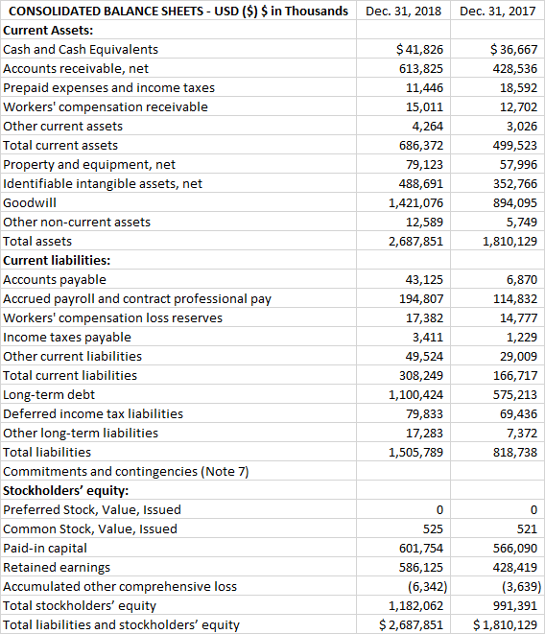

Income Statement:

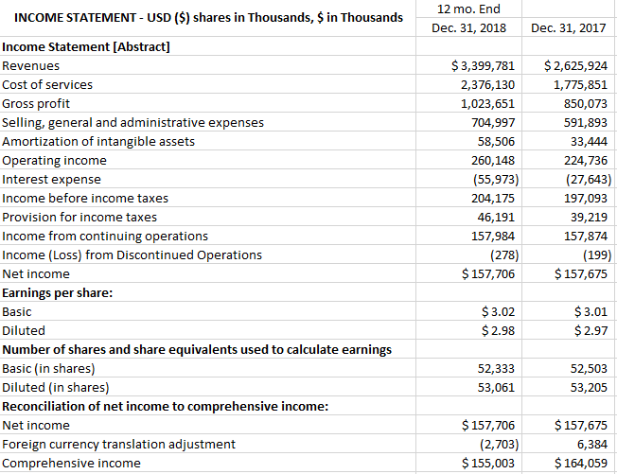

Growth Potential:

After deep analysis, we have found ASGN Incorporated to be a growth company. The company is a large player in the U.S. staffing industry, an industry that is growing. In 2019 the industry is expected to grow revenues by 4% and by 2020 it is expected to grow by 3%. A piece of this revenue growth is the increase in prices of the services. As technology prices increases, so does the servicing. The staffing industry is highly correlated with the technology industry.

Not only is ASGN part of a growing industry, they have been a leader of growth. Due to their size and service offering, they have grown faster than any of their competitors for 16 consecutive quarters. The company has not only been focusing on growing organically. They have sped up the growth through acquisitions. The most recent acquisition was ECS, a leader in advanced technology, science, and engineering solutions.

In February of 2019 the new subsidiary signed two contracts. One of the contracts was a five-year agreement with the US Mint Enterprise for $70 million. The other contract was six-year contract with the FBI for $38 million. The addition of ECS’ government services solutions have expanded ASGN’s business portfolio and helped it enter into the $130 billion federal IT services market. ASGN has a revenue goal of $5 billion by 2022, and we believe this is attainable. We looked back at past revenue goals the company has set and they have had solid results in the past.

Stock Mispricing:

As shown in the graph below, ASGN’s revenues have been growing quickly. However, the graph also shows the stock price growing at a fairly slow rate compared to these revenues. This chart lead us to believe ASGN’s stock may be mispriced.

There are a few key points to make on this graph. We looked into how ASGN’s operating margin has changed over the years, to make sure earnings follow about the same path as revenues. We found that the operating margins have not changed from 2016 to 2019 and are not projected to change.

We think an explanation for this large gap between revenues and stock price could be due to market overreaction. Acquisitions can be risky, and ECS was a large acquisition for the size of ASGN. However, ECS works primarily with the government, and we believe this alone takes a lot of risk away from the acquisition. The new subsidiary has also already proven to be successful by signing two large contracts. Risk also increased with the announcement of the fifteen-year CEO, Peter Damirist, stepping down from his role due to his son’s battle with cancer. He will however, remain on the board and the current president will be stepping up to take the position.

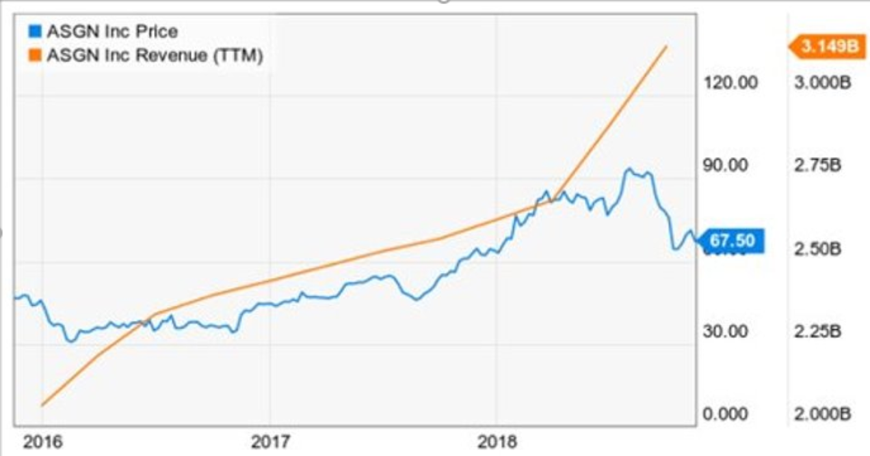

Free Cash Flow from Equity:

Looking at the free cash flow from equity, last year ASGN received $57.3 million or approximately 6% of their revenue through equity cash flows. FCFE displays the remaining funds after all expenses and debts have been paid for that period. ASGN has a quite strong free cash flow from equity, and this allows the company to consider new ventures and finance acquisitions such as the ECS company. This cash flow strength doesn’t show signs of slowing down either. Over the past five years, ASGN’s free cash flow has grown over 240%, and 50% from 2017 to 2018 alone. This happens to be a great tool for measuring ASGN’s value, especially since the dividend discount model can’t apply here since the company pays no dividends. Although, while on the topic, this cash flow can also present an opportunity to consider paying steady dividends to their shareholders.

Key Ratios:

Ratios | ASGN Inc. | Industry Average
ROA | 6.38% | 5.38%
ROE | 13.34% | 17.91%
Asset Turnover | 1.38 | 0.66
Working Capital | 2.38 | 1.54

As the chart portrays, ASGN is outperforming the industry in nearly every one of these categories. The only exception to this is the return on equity measure. But we don’t see this as weakness per se, but more as room to grow. Let’s say ASGN wants to expand, but they’re lacking in the funds to do so, using debt financing will raise their ROE, while providing additional financial leverage. The most significant ratio in the chart above is that of asset turnover. ASGN has over double that of the industry average. This essentially means that ASGN makes twice as much revenue per asset, compared to the industry averages.

Pro Forma Financials:

Looking at ASGN’s balance sheet and income statement, we can see that they are financially stable. Over the last few years ASGN has spent a large part of their budget on improving their equipment, expanding their service offering and acquiring other firms. For those reasons, we can see that the financial statements have been affected greatly, reducing their free cash flows and profit margins while increasing assets and book value. To see what ASGN would look like in the coming years, our team did an analysis to forecast their holdings at the end of 2019 and 2020. Through these pro forma financial statements, we get a number of interesting and useful ratios that help us along the investment decision-making process. We can also use these pro forma statements to make future estimates for stock price and annual revenues.

Unfortunately, with ASGN’s business strategy of large-scale investing and acquisitions, it makes it more difficult to accurately forecast those numbers without any inside knowledge of the company’s intentions. The information technology staffing industry is expected to grow at 4 percent in 2019 and 3 percent in 2020, given those numbers we were able to estimate an expected growth rate for ASGN. As a leader in the IT Staffing industry and through its recent acquisition of ECS, it is reasonable to expect that ASGN will grow at 13 percent in 2019 and a lower rate of 8 percent in 2020. Using those percentages, we systematically adjusted the balance sheet and income statement to reflect the appropriate increases.

The acquisition of ECS greatly affects ASGN’s equity accounts, leaving them with a smaller retained earnings balance at the end of the year. ECS was taken over in early 2019 for a cash consideration of $775 million. With those adjustments to their equity accounts, we were able to provide a more accurate forecast for the coming years. With revenues estimated to be at $3.8 billion in 2019 and $4.2 billion in 2020 we see rather significant increases in our operating and net profit margins, as well as in our return on equity and return on invested capital. Please see below for those forecasted ratios. With these numbers, we have more evidence to support our claim that ASGN is in a transitionary period before their big break that would make it the optimal time to invest.

 | 2018 | 2019 | 2020
Operating Margin | 7.65% | 11.74% | 13.37%
Profit Margin | 4.64% | 8.73% | 10.37%
Return of Net Equity | 13.34% | 23.07% | 36.46%
Return on Invested Capital | 21.24% | 32.82% | 37.55%
Conclusion:

The current market price of ASGN is $62.76. We have a 12-month target price of $70 based on 5-year history. We see huge growth potential in the staffing industry, and ASGN is a leader of that growth. The company has continuously grown since going public in 1992. The stock appears to be mispriced when compared to the companies quickly growing earnings. We believe that the Winona State Student Managed Fund should consider investing in ASGN Incorporated stock.

