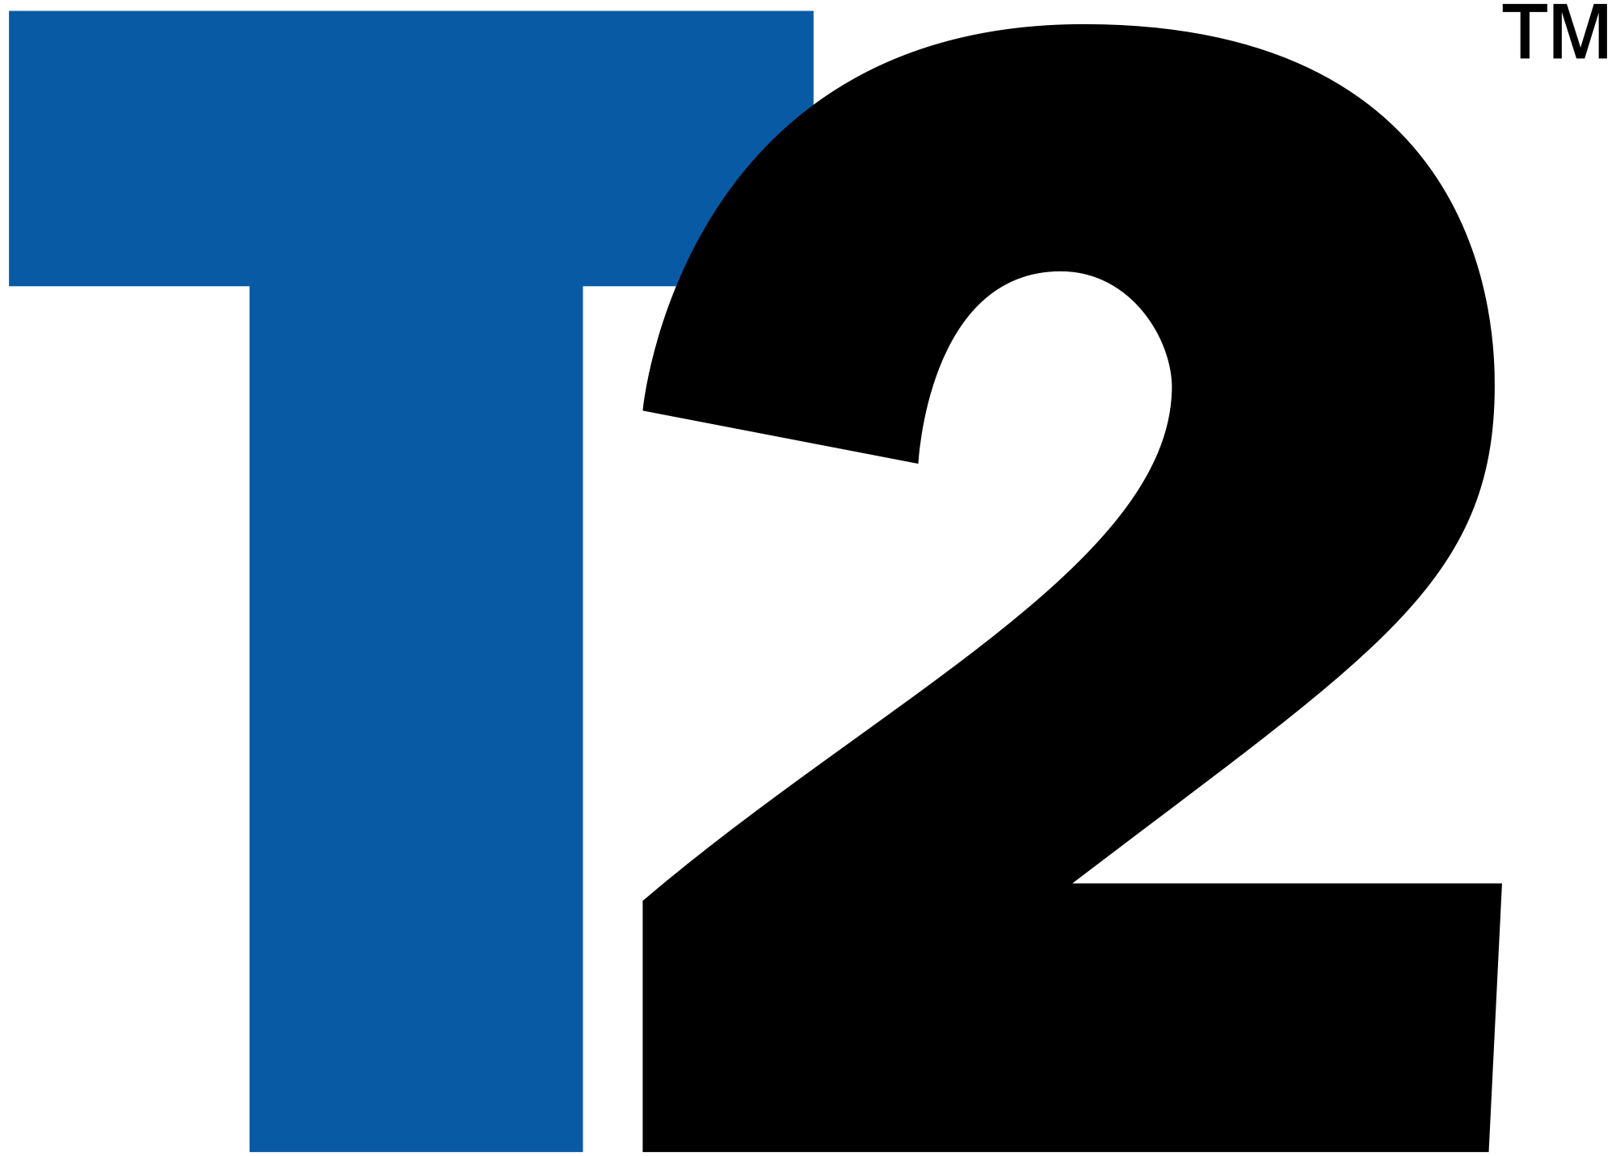

Equity Report
Take-Two Interactive Software
Tenner Stoe, Brent Bushman, Jake VanderBroek, Janak Sethi
Finance - 422
4/25/17

Basic Information
Take-Two interactive Software is a publisher and distributor of video games and traded under the ticker TTWO. It is traded on the Nasdaq stock exchange and is part of the Russell 2000. Take-Two is in the information technology industry and the software sector. As of 2016 their total assets were $2.6 billion and they have released many major game franchises such as Grand Theft Auto, NBA 2K and Civilization. They have mainly focused on console and PC games in the past but are moving into the mobile game market. Take-Two has seen steady growth in their stock price over the last 3 years, from around $16 a share to currently at $62. Their float rate is 88.4% and their largest shareholders are the BlackRock Institutional Trust Company with 9,012,131 shares and The Vanguard Group with 7,360,571 shares. Take-Two currently has a market cap of $6.4 billion and we believe this will continue to grow as they gain more of the market share in the industry. We are recommending to buy TTWO based on the growth we are expecting for the company.

Investment Summary
When looking at Take-Two there are some very promising strengths and opportunities for them in the future that will generate growth for the company. The strengths Take-Two has are its game recognition of its franchise games and continuous revenue from its yearly released games. The main franchise games such as Grand Theft Auto only come out every few years, but the brand recognition keeps people buying them and interested until the next one comes out. In the Fall of 2017 Read Dead Redemption 2 will be being released, which is the second installment in the franchise after the first game sold over 15 million copies. With the years between major game releases their NBA 2K and WWE 2K games that are released yearly help to generate consistent revenue. Along with the yearly games, their video games have downloadable content available to be purchased that expand the games and keep people interested and spending money beyond just the purchase of the game. With the release of Red Dead redemption 2 we are estimating a year over year revenue growth rate of 52%.
The major opportunities they have are getting into mobile gaming, the ability to increase downloadable content and creating new game franchises. The mobile gaming market is a growing field as more people have smart phones and what can be done on them is becoming more advanced. Take-Two is just entering this market and has a lot of potential for growth. The acquisition of Social Point in February allows Take-Two to become more competitive in the mobile game market and gain another source of revenue. Many mobile games are free to download but have optional in app purchases which would provide revenue beyond just a one-time purchase. With all opportunity to increase revenue we believe the stock is undervalued and will continue to have steady growth.

Business Description
Take-Two Interactive Software is a multinational publisher and distributor of video games. They wholly own Rockstar Games and 2K Games which develop Console (Xbox, Playstation) and PC video games. The most popular console franchise produced by these companies is Grand Theft Auto, which has sold over 230 million copies in its existence. Civilization is their most popular PC franchise, with over 40 million copies sold between six game series. Recently, Take-Two has started to broaden their game selection by moving into the mobile device market. In February 2017 they acquired Social Point, a free-to-play mobile game developer. Social Point has been successful in creating free games with in-game purchases on IOS and Android devices.
Take-Two is likely to benefit from the production of games in the mobile market using strategies from previous games. According to Exhibit 1, the graph shows a list of the most popular Take-Two game franchises and the number of copies sold per franchise.
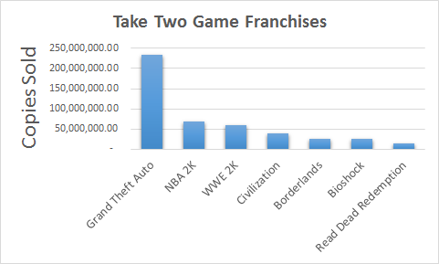
Exhibit 1:
The most popular game genres in the United States are listed in Exhibit 2. The reason Take-Two has been successful is because they focus on the most popular game genres: Shooter, Action, and Sport Games. They shy away from publishing games that will produce minimal sales or not be appealing to consumers. Since the average development cost per game is between $18 and $28 million, it is important to release high quality games that will be successful and produce positive revenue.
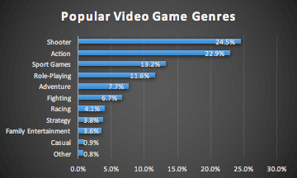
Exhibit 2:

Management & Governance
In 2010, Ben Feder stepped down as CEO, and was replaced by executive chairman Strauss Zelnick. The former CEO, who admitted to falsifying business records, was sentenced to five years probation. The price of one share of Take-Two was around $10 in 2010 and now trades for $63. Both the CEO and President are compensated not by a high salary but with shares in the company. Having a significant amount of shares means that their interests match the interests of the company.
Executive Officers
Strauss Zelnick (Started 2010) $22,000 Salary
Chairman and Chief Executive Officer
Karl Slatoff (Started 2013) $20,000 Salary
President
Lainie Goldstein (Started 2007) $3M Salary
Chief Financial Officer
Daniel P. Emerson (Started 2014) $2.4M Salary
Executive Vice President and General Counsel

Board of Directors
Michael Dornemann
Chairman and Chief Executive Officer
Robert Bowman
Lead Independent Director
J Moses
Director
Michael Sheresky
Director
LaVerne Srinivasan
Director
Susan Tolson
Director

Although having the CEO serve as Chairman of the board is now always wise, it is important to note that there is an independent Lead Director to facilitate other ideas. There does not appear to be any risk of entrenchment within Take-Two’s corporate governance.

Industry Overview and Competitive Positioning

Take-Two Interactive Software is in the industry of publishing and distributing video games. In this highly competitive industry, their main competitors are Electronic Arts and Activision Blizzard. These competitors have market caps of 28.3 Billion (EA) and 37.5 Billion (ATVI). Although Take-Two is a smaller company with a market cap of 6.3 Billion, it shows there is high potential for growth opportunities in this industry. In 2016, revenue was reported as $1.41 Billion for Take-Two, $6.60 Billion for Activision Blizzard, and $4.39 Billion for Electronic Arts. Below, Exhibit 3 shows the growth percentage in stock price for the peers in the previous five years. Take-Two has had very steady growth while outperforming Activision Blizzard, but underperforming Electronic Arts. One reason Electronic Arts has been on the rise since 2014 is credited to their success in the mobile gaming market. Take-Two has recently entered this market and their stock price will benefit with their release of mobile games through their subsidiary Social Point.
Exhibit 3:
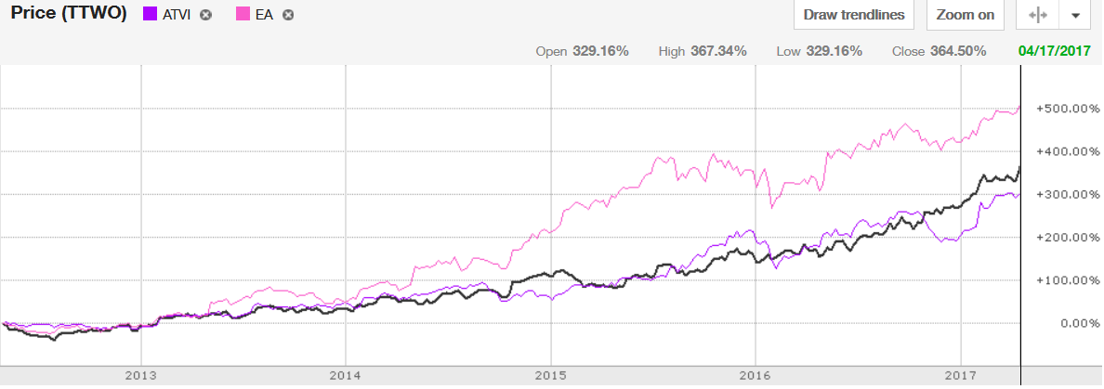

Valuation
We expect that the performance of the firm's new franchises could be a good indicator of the firm's medium- to long-term financial opportunity. In aggregate, we project the firm's average non-GAAP revenue growth to average 5.6% during the next five years. We expect fiscal 2017 to be a transition year with 4.6% non-GAAP revenue growth, as the company has a relatively weak slate. For the next four years, we anticipate average annual non-GAAP revenue growth of 5.8%, driven by 11.6% growth in digital online revenue, which more than offset the decline in physical sales. We envision the adjusted EBITDA margin expanding to 23.2% in fiscal 2021 after a decline to 13.0% in fiscal 2017, as the growth in high-margin digital sales and micro-transactions will be offset by ongoing research and development investments and lower physical sales.
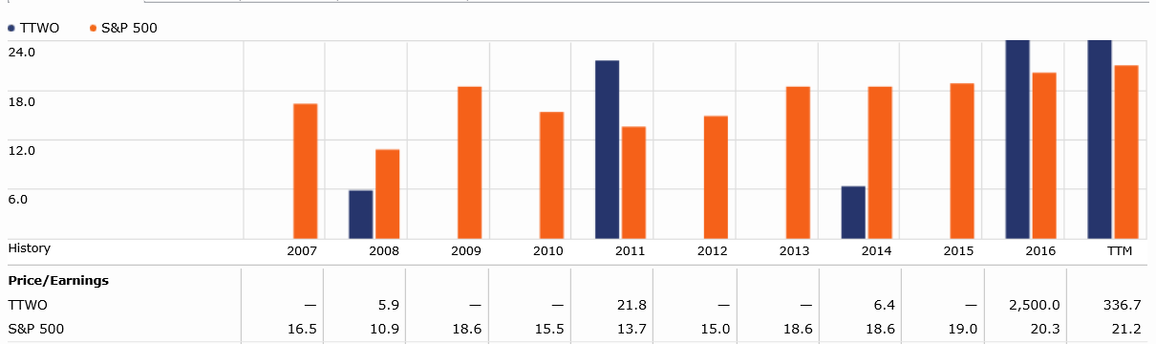
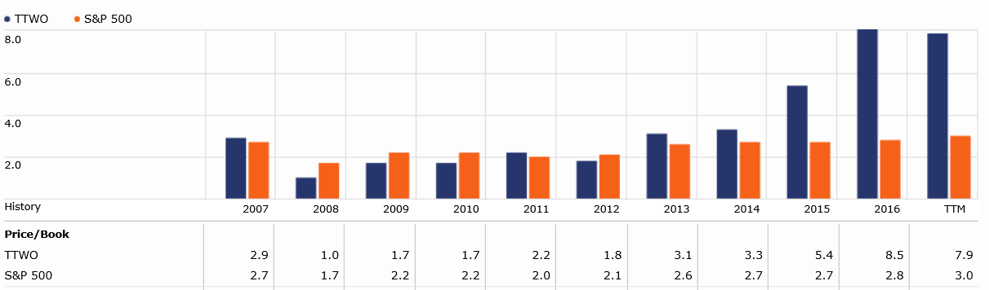
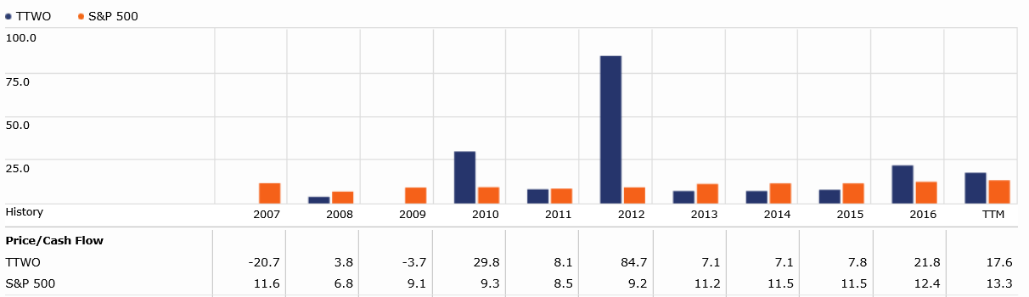
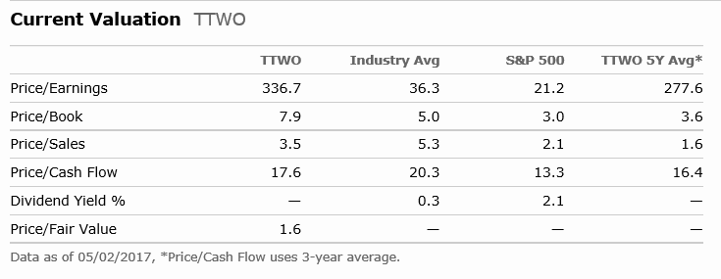

Financial Analysis
Take-Two reported a strong fiscal third quarter of 2017 as holiday revenue came in above predicted projections. Management raised its fiscal 2017 GAAP guidance to account for the beat. The firm acquired Social Point, a European mobile game developer best known for Dragon City and Monster Legend games. With shares trading above our projected fair value, we would seek a wider margin of safety before investing.
GAAP net revenue of $476 million (up 15% year over year) was driven by the deferred revenue recognition from Grand Theft Auto V, or GTA V, as well as the sales of new releases NBA 2K17, WWE 2K17, and Civ VI. Despite being originally released in 2013 and rereleased in 2015, GTA V was the sixth-highest selling game across all platforms in the U.S. in 2016 and has sold over 75 million copies worldwide since its debut as mentioned before. Digitally delivered revenue grew by 64% to $240 million with recurrent spending making 39% of revenue. Digitally delivered revenue is a fundamental metric to analyze company value. We continue to view recurrent spending as a potential source of relative growth for Take-Two versus its peers particularly as GTA Online and the NBA series remain popular with core gamers and the firm adds recurrent revenue opportunities to new titles. The strong quarter did not benefit from Mafia III which has already sold 5 million copies.
Take-Two purchased Social Point for $250 million (70% cash and 30% equity) with the cash portion coming from offshore reserves. Management expects the deal to be immediately accretive to net revenue and accretive to net income in fiscal 2018. Social Point generated over $20 million in net revenue for all four quarters of 2016 for a total net revenue of $91 million and EBITDA of $20 million, which again has grown consistently.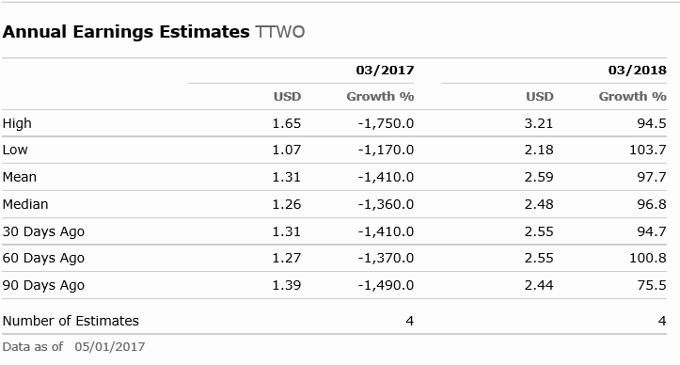

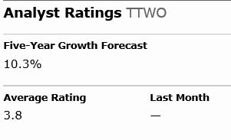

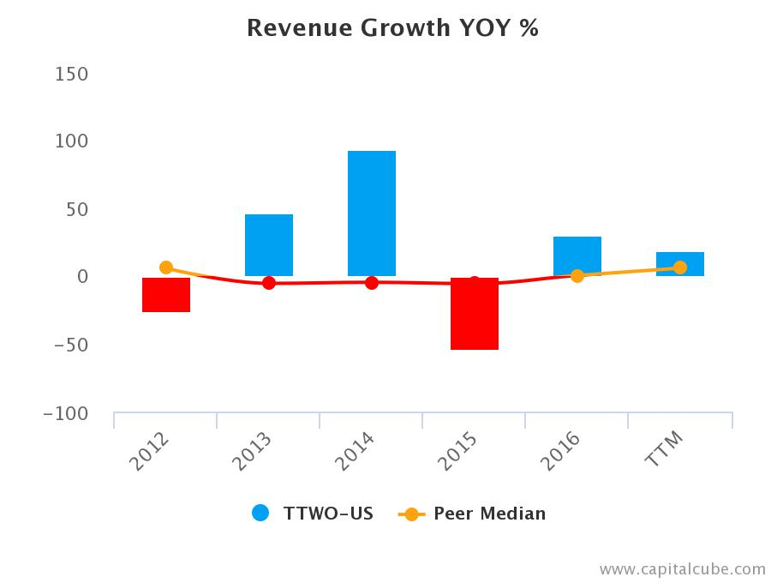

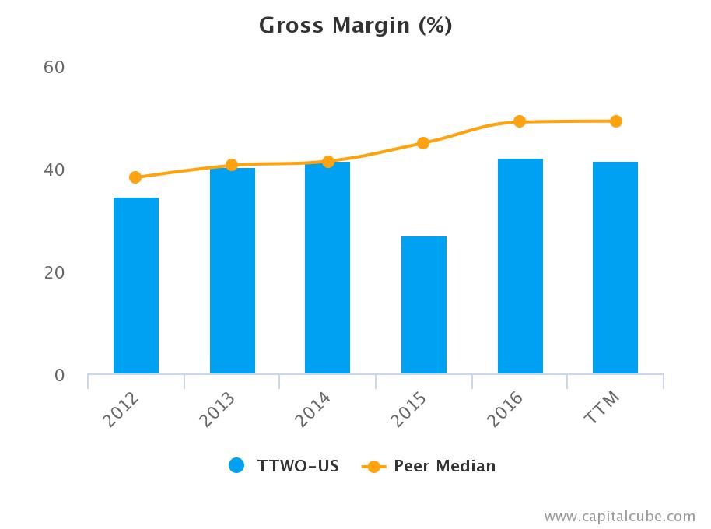

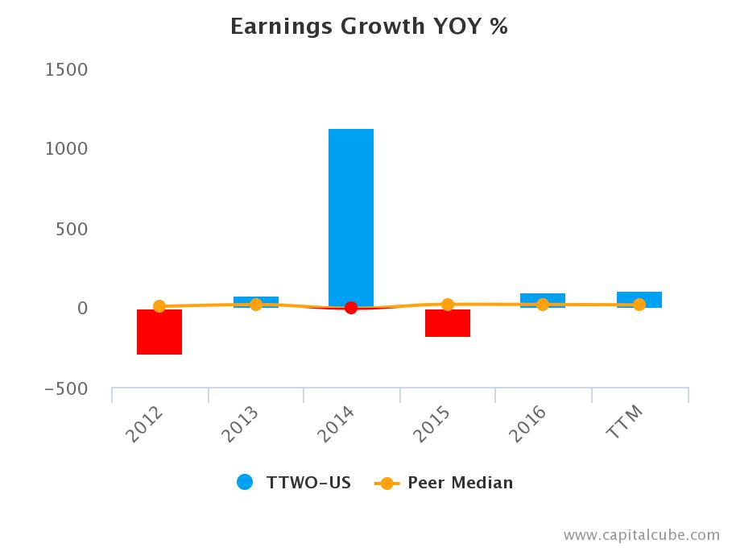

Investment Risks

One obvious risk with Take-Two is the risk of developing a high cost game with lower than expected sales. The cost of game development has been going up. It now costs on average between $18 and $28 million for video game development. If they invest too much capital on a failed game it would negatively affect the company. The cost to develop Grand Theft Auto V was $137 million in 2013. The development and marketing costs were well worth it in this case but not all games will be so successful.
Another issue within the industry is the rising cost of buying intellectual property. Take-Two will need to continue to acquire smaller companies to gain diversity and grow. Right now, Activision Blizzard, and Electronic Arts are much larger companies who can afford to produce a wider range of video games.
Less diversity than competitors, but that is getting better. In Take-Two’s growing years, it will be imperative to continue to develop profitable games in order to reach the level of their competitors. Because of its smaller size, they experience changes in revenue from year to year. Games like the 2K series and WWE do not bring in the kind of revenue like their big hit releases. Grand Theft Auto V has kept the company afloat through the years of low sales. The company needs to work on developing a system of bringing in more consistent revenue streams instead of relying on big name releases.

Sources: Yahoo.com
TdAmeritrade
NASDAQ.com

