Innoviva Analysis

Ticker on NYSE: INVA

Report by:
Nick Cimaglia
Isaac Westlake
Brittany Schyvinck
Sam Kohnle
Trent Seagren

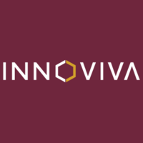

Company Overview:
Innoviva is a pharmaceutical company built around a core team of scientists who bring their unique fusion of pharmaceutical knowledge combined with quality financial management. Innoviva has been in business for twenty-three years while being public for the last fifteen years. Currently, Innoviva’s main task is royalty management as they hold three patents of respiratory medicine that are sold by GlaxoSmithKline. These patents are there main source of revenue and are a huge strength of the company. Additionally, Innoviva is very prominent on keeping their debt and corporate costs down. This is important for potential investors, as it is always Innoviva’s goal to maximize shareholders wealth. They have demonstrated their pledge to return value to shareholders through the capital return program they offer.

Industry Revenue Growth:
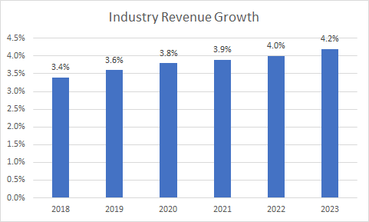
(figure 1.1)
Looking at revenue growth of the pharmaceutical industry, the graph above displays forecasted revenue growth over the next 5 years. As seen above, the pharmaceutical industry is projected to grow at an average of 3.8 percent over the next 5 years. This is excellent for Innoviva as they will continue to see an increase in revenue in their industry and hopefully capture more profit from this. We are not surprised to see this spike in industry growth as a result of new medicines and drugs being released that have the ability to cure diseases faster than ever. In comparison to Innoviva’s forecasted growth in royalties (which make up more than 99 percent of their revenue), located in figure 1.3, projected royalties in 2019 were expected to increase by 32.4 percent compared to the industry revenue estimated to increase by 3.6 percent. We believe both Innoviva’s projected royalty increase and the values represented above are accurate. Although Innoviva’s percentage is well beyond the industry average, we believe its accurate as they are currently in the third stage of developing a once-daily single inhaler triple therapy, which will be the best in the market.

Management Team:
Innoviva’s Management team is crucial to its success and growth as a company. The team drives company success from industry knowledge and innovation. With a fairly new management team, there is newly established ambition with big goals to be achieved around the growth of Innoviva. Below are two crucial players of Innoviva’s management team that make sure the company is staying on track and heading in the right direction.
Odysseas Kostas, M. D. is on Innoviva’s Board of Directors, and currently serves as their Chairperson. He has been the Chairman of the Board of Directors since April 2018. In addition to being Chairman, he is currently a member of the Audit and Nominating/Corporate Governance Committee. Through these positions, he has served as an engaged consultant to various biotechnology strategies. These positions have helped Dr. Kostas gain knowledge, and in turn he has brought his great pharmaceutical expertise and techniques to Innoviva.
Geoffrey Hulme plays a big role on Innoviva’s management team. Mr. Hulme’s was brought onto Innoviva’s team in May of 2018 and currently holds the title of Interim Principal Executive Officer. Prior to his hiring, he served as the owner and manager of Steel Valley Capital LLC. Additionally, he has served as Director of Research and Portfolio Manager for Amici. Through his 25-year career, he is extremely experienced in finance and investment management, with a record of creating and maximizing shareholder value. By bringing over his financial knowledge to Innoviva, Mr. Hulme’s was a great addition to team by helping boost Innoviva’s potential.
These two men have been played huge roles and their success can be seen in Innoviva’s financial statements. Recently, Innoviva’s strive for success includes the announcement of a new drug. The impact of this announcement can be seen in Innoviva’s first quarter financials. On May 2nd, 2019 Innoviva announced headline results from the pivotal phase 3 CAPTAIN study of once-daily single inhaler triple therapy TRELEGY® ELLIPTA® compared to RELVAR®/BREO® ELLIPTA®, in the treatment of patients living with uncontrolled asthma. The study was sufficient, demonstrating a statistically significant 110mL improvement in lung function. The result of this announcement impacted Innoviva’s first quarter report, which released on May 1st, 2019. Their total net revenue increased by 5.35 percent resulting in 55.2 million dollars. Furthermore, Innoviva’s first quarter net income in 2019 increased by 31.95 percent to 40 million dollars relative to their first quarter net income in 2018.
The success above is just one example of Innoviva’s excellent management team. The management team/board remains confident in the company’s long-term plans for revenue and profit growth, with strong experienced executives. Innoviva will continue to remain fully committed to delivering attractive returns for shareholders and growing as a company.

Innoviva’s Royalties:
Innoviva is a pharmaceutical company with big emphasis in Respiratory Medicine and royalty management. Over 99% of Innoviva’s revenue and net income come solely from these royalties. The advantage to receiving royalties is that Innoviva doesn’t have any cost of revenue, and thus their gross profit is exactly the same as revenues. Additionally, Innoviva currently has three major patents sold to GlaxoSmithKline, who in 2015 was ranked the sixth largest pharmaceutical company in the world. Innoviva’s portfolio includes the respiratory assets partnered with Glaxo Group Limited (“GSK”) (About Innoviva, 2019) “Under the Long-Acting Beta2 Agonist (“LABA”) Collaboration Agreement, Innoviva is entitled to receive royalties from GSK on sales of RELVAR®/BREO® ELLIPTA®, ANORO® ELLIPTA®, and TRELEGY® ELLIPTA®” (About Innoviva, 2019). Furthermore, Innoviva is also entitled to 15% of royalty payments made by GSK under its agreement to Theravance Respiratory Company, LLC (“TRC”), prior to Innoviva buying it.

Royalties Earned (Per Quarter):
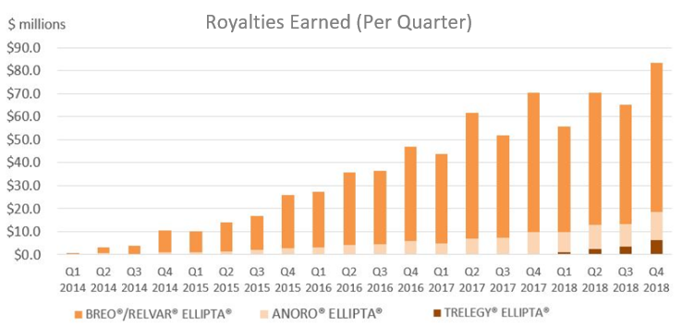
(figure 1.2)
Directly above is a chart showing the amount of royalties Innoviva earned (in millions) per quarter over the last four years from the products of GlaxoSmithKline. As mentioned earlier, Innoviva is entitled to 15 percent of royalty payments made by GSK, as well as the 3 patents sold to GlaxoSmithKline. The three products include, TRELEGY® ELLIPTA®, ANORO® ELLIPTA®, and RELVAR®/BREO® ELLIPTA®. TRELEGY® ELLIPTA® and ANORO® ELLIPTA® are relatively the same long-term prescription medicine. They are a one-a- day treatment for chronic obstructive pulmonary disease (COPD). This medicine helps with chronic bronchitis, emphysema, or both for better breathing and fewer flare ups. The only difference between the two is that TRELEGY® ELLIPTA® is not as good as ANORO® ELLIPTA® in combating flare ups. Both products by Glaxo are not used in the prevention of asthma. Glaxo’s main product, which produces the majority of royalty earned, is RELVAR®/BREO® ELLIPTA®. This is a combination medication for the treatment of COPD including asthma, chronic bronchitis, emphysema, or both, used to better breathing and cause fewer flare-ups. Additionally, this product helps fight asthma. This medication controls the class leading prescription of its kind in the U.S., with 41.1% of the market. Innoviva is entitled to receive royalties from all three of GlaxoSmithKline’s products. In addition to collecting those royalties, Innoviva will also receive 15% of the sales from these products until they receive a royalty amount of three billion dollars. After hitting the threshold, this 15% dissipates to 5% for all annual global net sales for the rest of the products life. Innoviva has currently received roughly 730 million dollars in last four years of royalty revenue from Glaxo. Based on the previous received royalties above, we have predicted that they will receive royalties at the 15% mark for the next 8-10 years.

Royalties compared to Net Income (Forecasted):
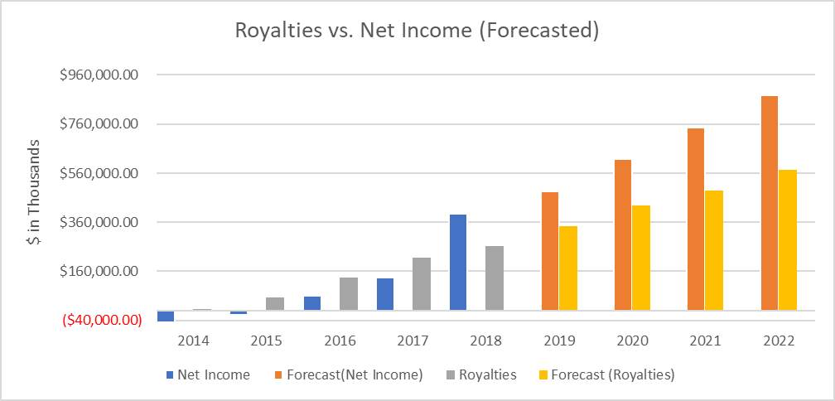
(figure 1.3)
Comparing royalties to net income is something that is necessary with a company that sees over 99% of its revenues from royalties. Looking at the chart above, in 2014 royalties were very low following an extremely net income. This changed 2016, when Innoviva saw almost $160,000,000 in royalties. Regarding 2018, Innoviva saw no revenue. Although there is a big gap between royalties and net income, there is an explanation for this. After taking out all expenses including tax on royalties, they must also deduct income tax expense. In 2018 this tax expense became a tax benefit amounting in roughly $400 million. From this tax benefit, net income was found after subtracting net income attributable to non-controlling interest, resulting in a net income of roughly $395 million. Looking at the following four-year forecast, Innoviva’s royalties appear to be very low risk and thus the discount rate should be low as a reflection of risk. Using Excel’s forecasting tool, starting in 2019, royalties are projected to increase by 32.4%. The following years are projected to increase as such: 24.3%, 13.7%, and 17.2%. Additionally, net income is expected to reach $877,720,000 in 2022.

Innoviva vs. S&P 500 (scaled):
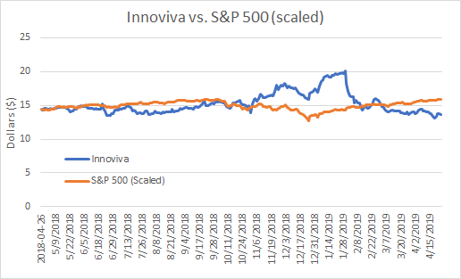
(figure 1.4)
This is a graph of Innoviva vs the S&P 500. Since, the S&P 500 is not the same price as Innoviva we decided to scale it down to make it more comparable. As you can see, when the S&P went down dramatically in December, Innoviva was strong and stock price rose. Innoviva did have a downturn when referring to stock price in late January and early February. This is because of a competitor named Advair, was able to get their generic version of the drug to fight COPD and asthma FDA approved. Which, in return, could potentially take some of the market share from Innoviva. We believe that investors are overreacting to the generic competition and ability to control some of the market, considering Innoviva has such great brand loyalty. If demand for Innoviva’s formulation does not drop and prices hold, royalty revenues should not fall as much as markets think, making Innoviva an ideal undervalued stock to invest in now. Thinking about the future of Innoviva’s stock price, we believe it will be on an uptrend considering Glaxo and Innoviva recently released results from the pivotal phase three study of a once-daily single inhaler triple therapy, TRELEGY® ELLIPTA®. In this study, they found that this new drug statistically proved a significant improvement in lung function. Innoviva found that this product was quite better than their best royalty product, RELVAR®/BREO® ELLIPTA®, regarding lung functionality. This new product is a three-in-one medicine to help fight COPD, chronic bronchitis, emphysema, and uncontrolled asthma, which there is no product currently available for this (Phase III, 2019). In turn, this creates an opportunity to invest in a growing stock at a very low price. After the news of this new product, Innoviva’s stock price rose almost a dollar in the same day, increasing over 7.33 percent for the day.

Average Ratios of Industry vs. Innoviva:
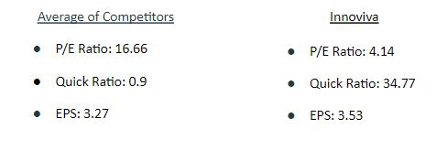

Looking at ratios, we found three that show the strengths of Innoviva at the best. These ratios include the P/E Ratio, quick ratio, and earnings per share. To find the data for our average competitors we took four companies around the same size as Innoviva and averaged out their ratios. First, looking at the P/E ratio, it can be seen that Innoviva is much lower than their competitor. We see this as a great time to buy as it shows that Innoviva is at a very large discount offering investors a low price to purchase stock. Following the P/E ratio, it is important to discuss Innoviva’s quick ratio as it’s 3,763 percent greater than that of the average of their competitors. Having such a high quick ratio shows Innoviva has minimal debt. Additionally, this ratio represents the liquidity of the company and shows how they have a huge margin of safety in case of an emergency. Ultimately, Innoviva’s earnings per share tell investors that they will receive a good return on their investment. Considering all four competitors are bigger than Innoviva, it is impressive to see that they offer a higher earnings per share than their competitors average. Having an earnings per share of three dollars and fifty-three cents is yet another attractive reason for potential investors.

SWOT Analysis:
Since 2014, Innoviva has experienced yearly increases in revenue and net income. This is one of their greatest internal strengths as a growing company. Their three major patents that they sold to GlaxoSmithKline provide a significant source of their revenue. Because they are smaller than some of their competitors in the pharmaceutical company, which could be a weakness, it is important that they have the aforementioned strengths to compensate.
Acquiring FDA approval is a lengthy and time-consuming process. Bringing a drug from the laboratory to the pharmacy shelves can take approximately 12 years. On average, only one out of 1,000 drug compounds from the lab will make it through to be tested on humans (Drug Approval Process, n.d.). Another external threat that Innoviva faces is the proposal President Trump made earlier this year to lower pharmaceutical drug prices. This does not pose a threat in the near future however, as industry analysts are skeptical as to how soon this would be in effect (Thomas, 2019). With new diseases and illness continuing to emerge, the opportunity for advances in modern drugs continues. The pharmaceutical industry is propelled by the desire to cure illnesses and diseases.

Investment Opportunities:
As seen above, it is without a doubt that Innoviva’s stock is currently undervalued. Having such a low P/E ratio compared to the industry average, this gives investors the opportunity to invest at such a low stock price. Additionally, Innoviva is a heavily royalty managed team due to royalties making up more than 99% of their revenue. Considering this company is heavily based on royalties, Innoviva has nothing short of an exceptional management team that is always looking to increase shareholders wealth. When looking at the pharmaceutical industry, it is projected to grow around four percent over the next few years. With new pharmaceuticals being released that have the ability to do much more than ones in the past, there will always be a demand for medicine, and thus we see this in favor of Innoviva. In addition to the industry growing, it always helps to be partnered with strong companies. Innoviva, being partnered with GlaxoSmithKline, gives them the ability to work with a well-known and well-trusted company. With Innoviva’s partnered companies growing, Innoviva is expected to see an increase in growth as they will continue to see more revenues from these royalties.

References:
About Innoviva. (2019). Retrieved from https://www.inva.com/
Drug Approval Process Information. (n.d.). Retrieved from https://www.drugs.com/fda-approval-process.html
“Phase III CAPTAIN Study of Trelegy Ellipta in Patients with Asthma Meets Primary Endpoint.” Yahoo! Finance, Yahoo!, 2 May 2019, finance.yahoo.com/news/phase-iii-captain-study-trelegy-161800695.html.
Thomas, K., & Abelson, R. (2019, February 05). How Trump's Latest Plan to Cut Drug Prices Will Affect You. Retrieved April 15, 2019, from https://www.nytimes.com/2019/02/05/health/drug-prices-rebates-sotu.html

