Equity Report

Miranda Bergsrud
Cory Carlson
Timothy Garcia
Dustin Hinck

Business Description

Highwoods Properties, headquartered in Raleigh, North Carolina, is a publicly traded real estate investment trust. They own, develop, acquire, lease and manage properties in the districts of Atlanta, Greensboro, Nashville, Orlando, Pittsburgh, Raleigh, Richmond, and Tampa. These districts are known as Best Business Districts, or BBDs. Highwoods Properties’ strategic plan is to own and build in the most dynamic and vibrant submarkets. These BBDs are highly energized, infill business communities that enhance their customer’s ability to attract and retain employees and their own customers. These locations are surrounded by amenities and well-located within larger metropolitan areas. These BBDs have steady to increasing economic growth and job growth in southeastern markets. Nashville, Raleigh, Atlanta and Florida markets continue to post some of the highest job growth and population growth rates across the nation and there is no sign in that slowing down anytime soon. The BBD locations continue to outperform their broader markets with rents on average 4% higher.
Highwoods Properties has a market cap of $4.57 billion and current stock price of $44.60. They focus mostly on the REIT industry and competes for rental properties with a number of other office REITs, as well as other real estate companies. Highwoods Properties has a $440 million development pipeline that is 78% pre-leased. This will provide them strong cash flow and FFO upon delivery and stabilization over the next two years. There is continued conversation of additional pre-leased and build-to-suit prospects.

Management

Senior Leadership
Ed Fritsch
President, Chief Executive Officer and Director
Ted Klinck
Executive Vice President, Chief Operating and Investment Officer
Carman Liuzzo
Senior Vice President, Investments
Jeff Miller
Executive Vice President, General Counsel and Secretary
Mark Mulhern
Executive Vice President and Chief Financial Officer
Randy Roberson
Senior Vice President, Development
Mike Starchville
Senior Vice President, Asset Management
Brendan Maiorana
Senior Vice President, Finance & Investor Relations

Ed Fritsch joined Highwoods in 1982 and held many titles before becoming CEO in 2004. He was also a partner of Highwoods’ predecessor company before its initial public offering in 1994. As CEO, he has implemented a successful business strategy focused on four concept principles: people. Portfolio, balance sheet and communications.

Board of Directors
Temple Sloan
Chairman of the Board, member of the Compensation/Governance and Investment Committees
Chuck Anderson
Member of the Investment and Audit Committees
Gene Anderson
Member of the Investment and Executive Committees
Carlos Evans
Chair of the Compensation/Governance Committee and member of the Executive Committee
Ed Fritsch
President, Chief Executive Officer and Director
Dr. David Hartzell
Member of the Audit and Investment Committee
Sherry Kellett
Chair of the Audit Committee
Anne Lloyd
Member of the Audit Committee

Industry Overview & Competitive Positioning

Highwoods Properties’ competitors include Alexandria Real Estate Equities, Cousins Properties Incorporated, Liberty Trust Property and Brandywine Realty Trust. Overall, Highwoods Properties is outperforming their competitors, or is right behind them when it comes to their financials.

 | Capital Expenditure Coverage | Return on Invested Capital | Cash Return on Invested Capital
HIW | 1.8 | 3.6 | 3.7%
ARE | 0.3 | 2.3 | -10.6%
BDN | 2.9 | 2.1 | 3.1%
CUZ | -4.2 | 1.4 | 6.7%
LPT | NA | 6.3 | NA

The Capital Expenditures Coverage Ratio is the amount a company outlays for capital asset for each dollar of cash dollar it generates from those investments. When it is high it iis good for growth and shows sufficient capital to fund operations. It also shows how much of the profits from operations they are investing into capital investments rather than borrowing. This ratio helps investors and analysts understand a company's ability to buy more assets, and do so without having to issue debt or equity. Highwoods Properties has been growing over the past few years and this shows that they have potential for growth which usually increases shareholder wealth and stock price.
Highwoods Properties shows great return on invested capital compared to its competitors and has been growing over the last few years. This shows that Highwoods is good at turning their capital into profits.
Lastly, the cash return on invested capital is fairly similar to the return on invested capital but when measuring return it doesn’t include those that are financed by debt. Highwoods is fairly average compared to their competitors in this ratio but a positive percent shows they are able to turn their invested capital into cash.

Competitors and Selected Financial Data

The chart below provides an overview of Highwoods Properties and their peers, in terms of revenue (blue) and net income (red). It is important to note that one time sales gains are included in this figure which can make certain competitors appear more attractive or efficient. For example, Cousin’s Properties and Liberty trust properties had one time sales gains of over 150 million while Highwoods did not have any this year.

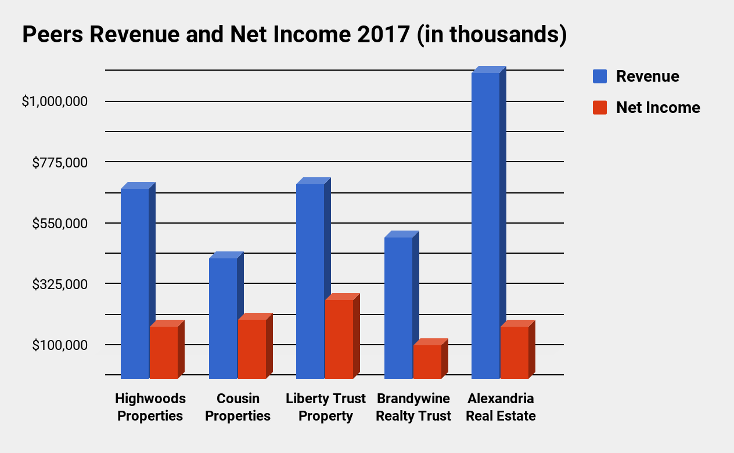

The Funds From Operations or FFO is shown for Highwoods and their competitors below. The use of FFO rather than earnings per share is because of cost accounting methods that my inaccurately portrait Real Estate Investment Trusts’ true value. Additionally, FFO is a more efficient way of gauging a REIT’s ability to generate and pay dividends. Funds From Operations compensates for these accounting principles by adding depreciation and amortization back into revenue, while also subtracting any one time sales. Highwoods Properties has been very consistent over the years with reasonable, steady growth in FFO. This is due to their strong balance sheet and strategic plan to stay within their local markets and maintaining a high market share, rather than expanding and having to compete more competitively.

In 2017, Highwoods announced a 3.5% dividend increase, and as of February 2017, that has been increased by another 5.1%. Highwoods has been consistent in dividends throughout their 40 years. They have been able to maintain these dividend levels through multiple market fluctuations, including the recent financial crisis. Highwoods Properties has a consistent growth strategy and appear to have a way to maintain and even increase dividends in the future.
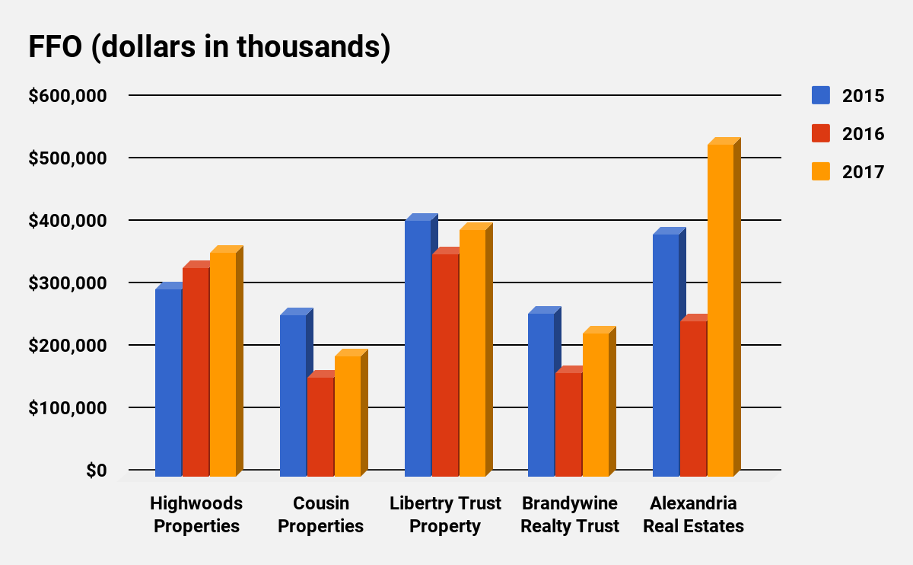

Valuation Model/Financial Analysis

For our valuation model, we predict that Highwoods Properties will have continued growth through their new development pipeline. Our valuation takes into account the growth through economic values increasing. Due to this, we used a short term growth rate of 6% and a long term growth rate of 3.5%. Also, we used a weighted average cost of capital of 6.41%. This gave us a price per share of $48.59 for Highwoods, which is about 5 dollars higher than the current stock price of $43.18. The model below shows all of our specific values by year. It can be seen in the model how the FCF grows, which is an important component for REIT firms. Highwoods has done a great job managing all of their assets and keeping their cash flows invested in new projects. With our current valuation, we can see that the market is currently undervaluing Highwoods Properties’ stock.
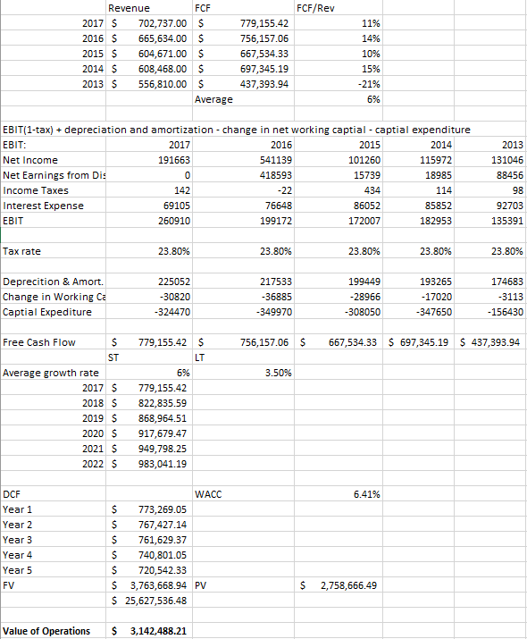
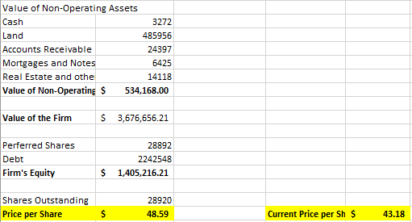
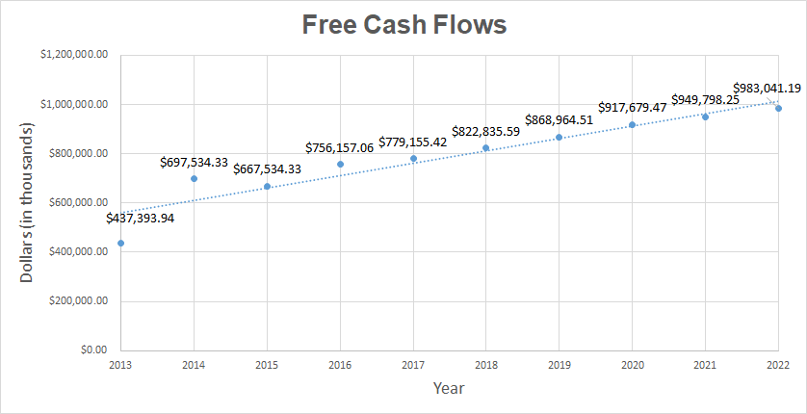

Investment Risk

Highwoods Properties has various risk factors that can significantly increase investment risk. Adverse economic conditions in local markets could have negative impacts on the demand for office space. If local markets have high unemployment rates, it may result in lower occupancy rates for the Highwoods portfolio.

Acquisitions and/or the development of properties may fail to perform at the high level of standards that is expected by Highwoods, and my require further renovation or development that exceeds the original budget. Additionally, renegotiating similar leasing terms may not be possible and result in reduced renewals or re-let space.

Interest rate levels will continue to be a risk factor for Highwoods Properties. As of December 31st, 2017 Highwoods had $605 million in variable rate debt outstanding not protected with interest rate hedge contracts. Variable debt may be used in the future, which means any interest rate increases will increase Highwoods interest expense and any unhedged variable debt, which could adversely affect their financial conditions.

Conclusion

We believe that Highwood’s stock is currently mispriced. We can tell this by looking at our analysis and valuation model. With our model, we came up with a share price of $48.59 and the stock is currently trading for $43.18. Due to this, we would recommend buying this stock. Based on the past three years, this company is showing consistent growth in to the future. Another important note is the economic growth of the cities Highwood’s has investments. 70% of their revenue is from properties in Atlanta, GA, Nashville, TN, Raleigh, NC, and Tampa Bay, FL. All of these cities show annual economic growth well above the national average. Also, there is a divide between current REIT stock prices and the value of their assets. Overall, we believe this stock is a strong buy.

