Fastenal

Equity Research Report

By: McKenzie Fortier, Ericka Gallun, Nicholas Gabriele, Jonathon Wodarz, Gavin Marty, Abby Archambault

Highlights
We initiate coverage on Fastenal (FAST) with a Hold recommendation based on a target-price of $55, offering a 2.9% upside from its closing price of $53.43 on December 7, 2017. Our recommendation is primarily driven by:

- Growth Drivers- Vending machines
- Management Platform- Warren Buffett has publicly praised management for their straightforward business plan, boosting sales by increasing interaction with customers and cutting costs where possible. The management team is bred from in-house leaders who understand the Company's singular focus on profitability.
- Competitive Advantage
  - Impressive cost savings for a variety of products due to competitive economies of scale.
  - Offer customer-tailored industrial solutions
  - Store network and trained personnel offers a package of products and services
  - New implementation of the ‘FAST Solutions’ On-site locations reduce customer transaction costs

Business Description
Fastenal is a machining and industrial supply distribution company headquartered in Winona Minnesota. Since its inception in 1967, it has grown to over 2,500 stores in 21 countries across the globe. While originally supplying fasteners, such as nuts and bolts, it’s catalog now consists of over 690,000 skus of industrial service products. Fastenal’s stock is traded in NASDAQ under the ticker FAST. It has a current price of $53.43, and a market cap of $15.4 billion.

Management
Fastenal has strong and competent management. In 2015, Leland Hein stepped down, allowing Daniel L. Florness to take over as Fastenal’s Chief Executive Officer. Dan Florness has been with fastenal since 1996, and from 2002-2015 he served as an Executive Vice President and Chief Financial Officer. Fastenal’s current CFO is Holden Lewis, who previously worked as an equity research analyst for top investment banks in New York City. Also, they are an extremely frugal company from the top down, which has helped reduce costs and save money over the years.

Industry Overview & Competitive Positioning
Fastenal along with its subsidiaries, engages in the wholesale distribution of industrial and construction supplies internationally. Fastenal’s competitors include large distribution centers such as W.W. Grainger and MSC Industrial Direct Co , and smaller distributors such as HD Supply Holdings located in many of the smaller markets that Fastenal currently operates in. With over 2,500 store locations and a strong principal for customer service, pricing, cost saving, and product availability, fastenal poses as a large threat to many smaller distributors.

 | P/E | D/E | Profit Margin | ROE | Operating Margin | ROA | Gross Margin
FAST | 26.10 | 0.20 | 12.73% | 27.50% | 20.10% | 19.08% | 49.60%
HDS | 10.95 | 3.60 | 8.47% | 32.76% | 10.30% | 7.82% | 33.50%
GWW | 23.83 | 1.30 | 4.83% | 26.04% | 11.00% | 11.42% | 40.60%
MSM | 20.17 | 0.20 | 8.08% | 17.59% | 13.10% | 11.61% | 45.00%
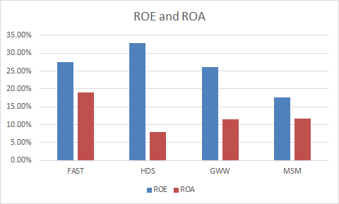
Overall, Fastenal has more attractive financials than its competitors. Looking at ROE and ROA you can see Fastenal is most efficiently using its assets to generate earnings, and that it is
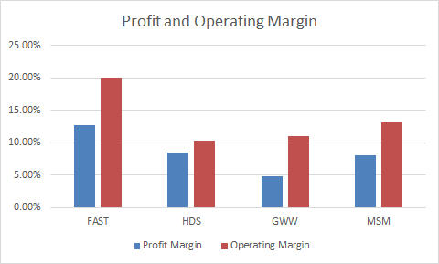
competitive regarding the profit it generates from the money shareholders invest. Looking at Profit Margin Fastenal is above competitors meaning they keep more in sales. When it comes to Operating Margin Fastenal is much higher than its competitors which shows how well the business model of the company is functioning compared to its competitors. Fastenal is likely doing better than the industry because of their low cost operating model which allows them to deliver products to customers at much cheaper prices than competitors and still make money. Other notable ratios amongst competitors include P/E and D/E. Looking at P/E you can see that Fastenal is trading at a better value than competitors. And with D/E Fastenal is the lowest showing an ability to better generate enough cash to satisfy debt obligations.

Investment recommendation summary
After months of extensive research and analysis of Fastenal, we ultimately came to the decision to buy. Fastenal is a great and promising story with the financials to prove it. In Fastenal’s most recent earnings report (Q3) they reported a 15% increase in daily sales, a number they have not seen in over three years. As well as daily sales increasing, sales have also been steadily increasing at a double-digit pace, at 11.3%. As far as the bigger picture goes, we observed that besides 2015-2016, Fastenal’s free cash flows have been increasing, and will continue to do so according to our five year FCF forecast.

Industrial vending machines are rapidly taking up revenue share. Since implementing the vending machines in 2008, Fastenal has installed over 69,000 devices (up 13.4% since 2017 Q2), and the revenue they have generated constitutes 16% of total revenue, or $640 million dollars. Fastener’s and non-fastener products still occupy the remaining $3.36 billion dollars of revenue.

As far as competitors go, Amazon is one of the largest that Fastenal must go against. We had the chance to speak to Holden Lewis, Fastenal’s Chief Financial Officer, and Holden was the least bit worried regarding their competitors, mainly Amazon. Wall Street thinks Amazon will eat into Fastenal’s business, but because of their delivery systems and the services Fastenal provide Amazon is not a threat. Since Wall Street incorrectly assumes that Amazon will have a bad effect on Fastenal this is a source of mispricing.

Potential Risks
Most of Fastenal’s customers are in the manufacturing and non-residential construction markets. Much of the construction is done in road, and oil exploration. Should oil prices drop due to a decrease in demand and renewable energy sources gain ground, the stock performance could see a dip as oil companies drill less.
Also, A key in Fastenal margins is being able to transport goods at a lower rate than competitors, and should a more efficient firm begin selling in the same market (Amazon) they may be able to come in at a lower price and undermine Fastenal’s sales.

Financial Analysis

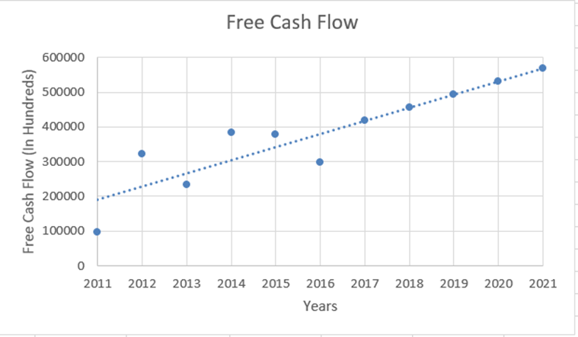

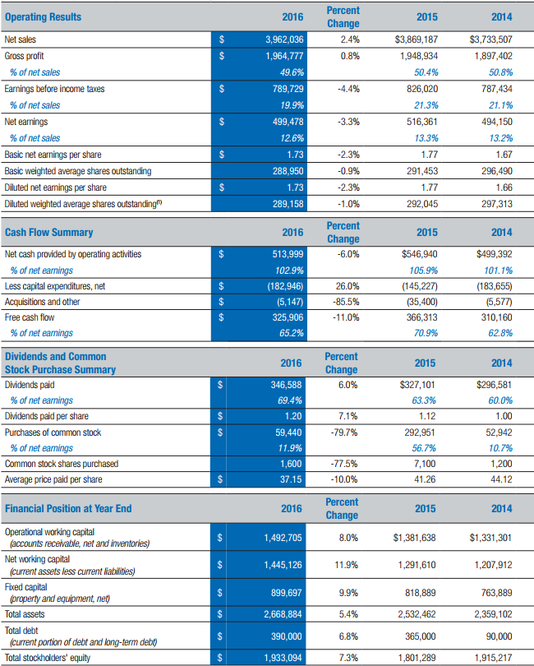

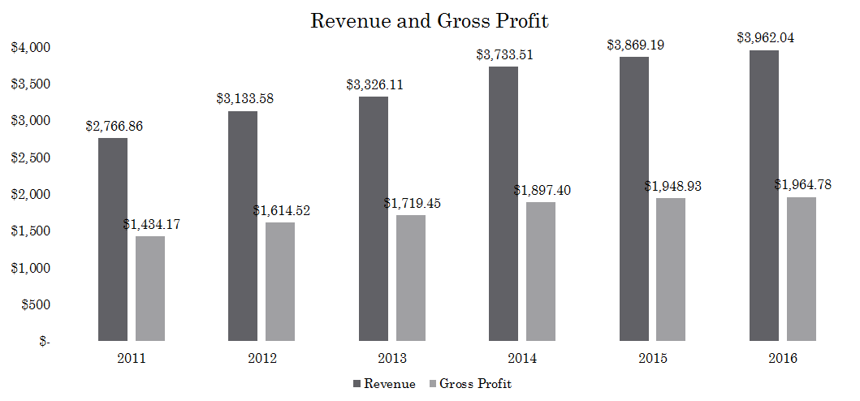
Over the last few years Fastenal has seen a steady gain in revenues. This healthy increase in revenues has also increased profits, except for in 2016. All in all the continued growth has allowed Fastenal outpace competitors in dividends as they have exploded.
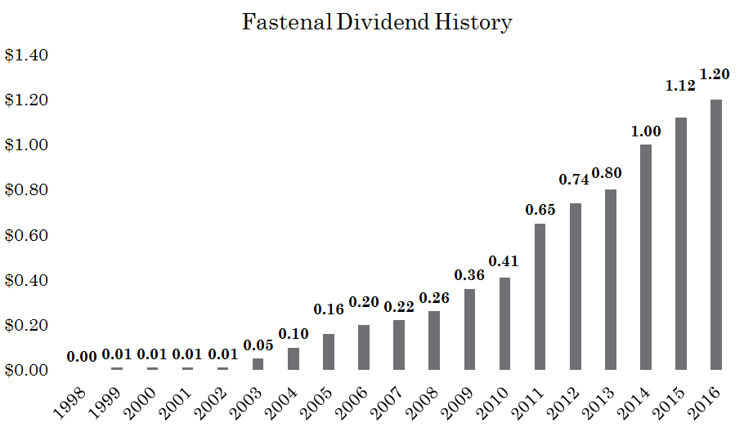

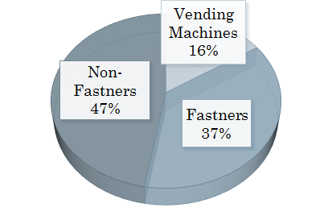
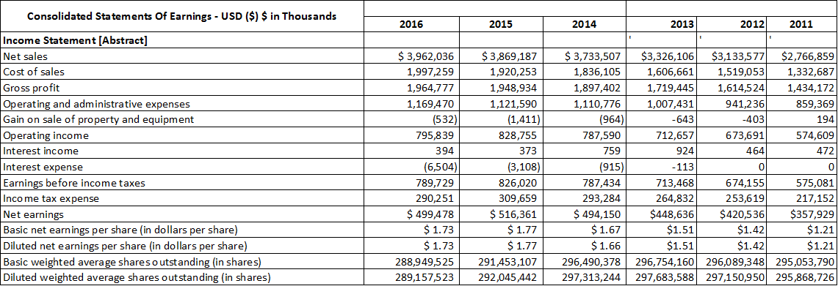
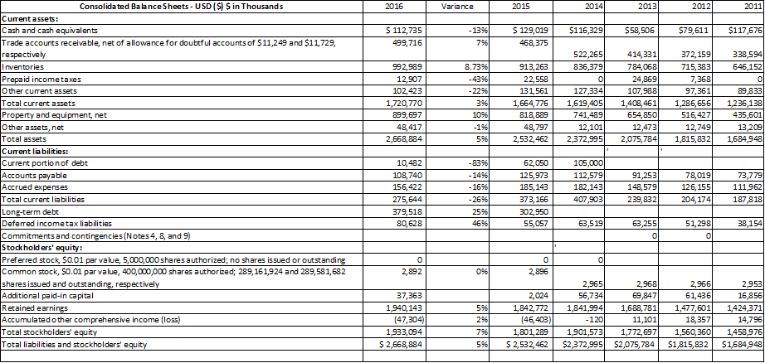
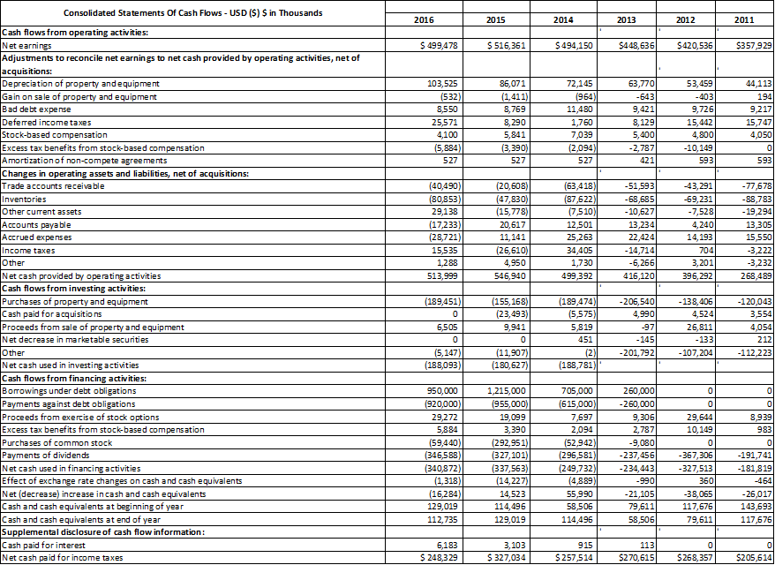
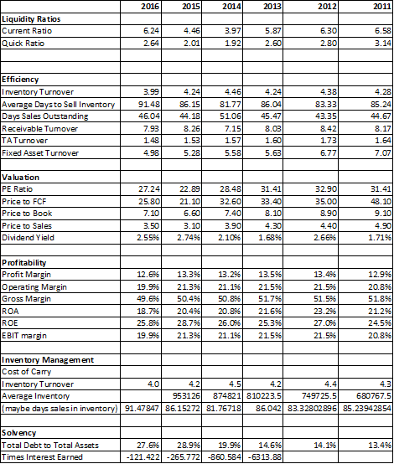

Potential Risks
Most of Fastenal’s customers are in the manufacturing and non-residential construction markets. Much of the construction is done in road, and oil exploration. Should oil prices drop due to a decrease in demand and renewable energy sources gain ground, the stock performance could see a dip as oil companies drill less.
Also, A key in Fastenal margins is being able to transport goods at a lower rate than competitors, and should a more efficient firm begin selling in the same market (Amazon) they may be able to come in at a lower price and undermine Fastenal’s sales.

