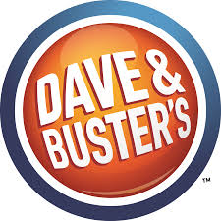

Kathryn Beckett, Cody Hougom, Tanner Lammers,
Jacob Lavan, Jordan Lipkie
FIN 422
Dr. Larry Schrenk
4.26.2018

BACKGROUND

During the 1970s a guy named Buster opened a new restaurant in Little Rock, Arkansas called “Buster’s” that became known for its delicious food and superb service. Next door to the restaurant that Buster opened up was a guy named Dave who had also opened up a business called “Cash McCool’s.” Dave’s business incorporated both entertainment and games for adults who were attracted to having fun. The two noticed that customers were actively moving between both locations, so they ultimately decided to form the idea of combining their businesses to best improve their profitability. In 1989, a company called Edison Brothers Stores financed expansion of Dave & Buster’s into other cities and established themselves as the majority ownership of the restaurant chain. On December 2005 the company was acquired by Wellspring Capital Management and later launched an IPO in 2014 and Dave & Buster’s officially went public. Since Dave & Buster’s have conjoined businesses they have incorporated state-of-the-art games, a broader, more delicious assortment of food items to their menu and also added creative and innovative drinks to their establishment. The company’s headquarters are located in Dallas, Texas and currently have 108 locations within the United States and have even added two locations in Canada.

BUSINESS DESCRIPTION

Dave & Buster’s is an American restaurant and entertainment business where food collides with adult beverages and fun and games. Dave & Buster’s moto is “Eat, Drink, Play, Watch, all under one roof!” There are more than 85 entertainment complexes that offer casual dining, full bar service, and a cavernous game room. The company attempts to differentiate themselves from other casual dining concepts by integrating their “remarkable & realistic” strategy. This promotes exceptional food that customers will want to “remark” on social media, while keeping it realistic in the way its functional in terms of operational time. The menu is offered early lunch until late night. It is designed to appeal to a large target market offering a wide variety of food including pastas, burgers, steaks, seafood, chicken, and desserts. To ensure satisfaction, they release menu updates nearly three times a year. Every venue also offers a full bar including a variety of beers, signature cocktails, and premium spirits. They offer fun beverage platforms including glow kones. The game rooms offer the latest video games and motion simulators in addition to old school games that are played for prizes, while still offering traditional games such as billiards and bowling. The games are operated with Dave & Buster’s Power Card, replacing traditional tokens. These cards act as company debit cards where customers can upload money at “power stations.” This is Dave & Buster’s attempt to adapt with technology, promote extended play time, and increase customer spending. Each venue on average has 40 high definition televisions offering sports-viewing and broadcasting of various live streams of Ultimate Fighting, WWE, and other sporting events. The company also offers services including professional event planners to help plan your event from start to end, while working within your budget. Dave & Buster's promotes these four products on an individual level in addition to groups by offering are company events, team building activities, adult socials, youth socials, and kids birthdays. The key driver of revenue is their amusement sector. The main sources of expenses are food and beverages, operating payroll and benefits, and store operating expenses.

MANAGEMENT & GOVERNANCE

Dave & Buster’s management team is a seasoned and skilled management team. The average amount of experience is 25 years in the relevant industry that Dave & Buster’s resides in, which is the food, drink, and entertainment industry. Before Stephen King became CEO of Dave & Buster’s, he was in charge of Carlson Food WW Inc, which at the time owned TGI Fridays and Pick Up Stix. Brian Jenkins, the CFO of Dave & Buster’s was Vice President of Six flags for six years before joining the team in 2006. Margo Manning the COO has been with Dave & Buster’s all throughout the company and has extensive knowledge of the company. Sean Gleason the CMO was with Yum Brands from 1995-2005 and with Cadbury Schweppes from 2005-2008 before joining Dave and Buster’s. Kevin Bachus, the SVP of Entertainment & Games Strategy has extensive knowledge in the gaming industry, most notably working for Microsoft developing the Xbox console and some Xbox successful games. John Mulleady, the SVP of development has been with the company since 2012. John has extensive knowledge in real estate. Previously, working as the director of Real Estate of BJ’s Wholesale Club from 2008-2012 and VP of Real Estate at Circuit City Stores, Inc (2006-2008). Jay L. Tobin has served as the Senior Vice President, General Counsel and Secretary since May 2006. Previously, Jay served in multiple capacities from 1988 to 2005, he served in various capacities (most recently as Senior Vice President and Deputy General Counsel) at Brinker International, Inc., a company that owns and operates casual dining restaurants worldwide.

INDUSTRY OVERVIEW & COMPETITIVE POSITIONING

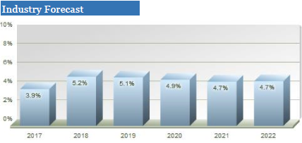
Dave & Buster’s operates within the entertainment and casual dining industries. The casual dining industry includes companies that provide food services in casual atmosphere including national and regional chains, franchise, and independent operators. The industry in the US produces an annual revenue of $225 billion and includes about 245,000 establishments. Demand for personal dining is driven by person income and demographics. The overall health of the economy is a large factor in the way consumers have more disposable income, they will be more likely to spend it in casual dining. Demographics is important in the way the restaurant should be easily accessible, driving demand. The overall profitability of a company is dependent on profit margin and effective marketing. Large companies have advantages in marketing and access to capital, while smaller companies have opportunities by focusing on offering higher quality food and customer service. This is a highly fragmented industry with the top 50 companies generating 20% of the total revenue. Current industry opportunities include increase alcohol sales, marketing through social media, targeting millennials, and growth potential small markets. According to Mergent Intellect, the casual dining industry is expected to increase at an annual rate of 4% over the next 4 years. The Amusement Parks & Arcades Industry includes about 3,2000 establishments with an annual revenue of $17 billion. Demand is driven by consumer income. This is a highly concentrated industry and according to Mergent Intellect the industry is forecasted to grow at an annual rate of
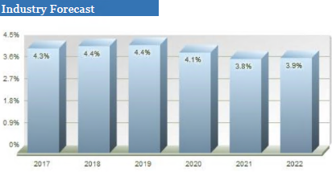
5% over the next 4 years. Major arcade operators US-based include Chuck E Cheese’s and Dave & Buster’s. Demand is driven by consumer income and the profitability of companies is dependent upon marketing skills. Current business trends include complementary business developments and debit card payment systems. Arcades are threatened by at home game and entertainment systems.

Dave & Buster’s is unique in the way they offer the four elements of eat, drink, play, and watch all under the same roof. This combination creates an experience under one roof that cannot be easily replicated. There is not any company quite like Dave & Buster’s, making it difficult to get an accurate comparison. They consider their main competitors to be Buffalo Wild Wings, Famous Dave’s, Texas Roadhouse, and the Cheesecake Factory. Although there are a few similar companies such as Brunswick Bowling and AMF Bowling, they are not public companies, making it difficult to get an accurate comparison.

GROWTH STRATEGY

Dave & Buster’s currently owns and operates 106 stores in the US and Canada, which are all company owned. By the end of 2017, Dave & Buster’s will have added roughly around 14 new stores and plans to add an additional 14-15 new stores by the end of 2018. After 2018, the company plans to grow its store count by an average of 10% each year. In North America alone, Dave & Buster’s has the capability to expand anywhere from 231 to 251 stores in new and already existing markets. This growth strategy will be mainly spearheaded by the addition of the already large (300k> sq. ft) store formats and small store formats (<300k sq. ft) which will account for roughly around 90% of the additions. Dave & Buster’s is also introducing the new 17K sized store formats, which is a new store concept made to cater to smaller newer markets with populations ranging anywhere from roughly 300,000 to 500,000 people.

With Dave & Buster's effective and efficient business model and expansive strategies into new and older markets, Dave & Buster's also relies heavily on menu and entertainment innovation to drive its in store sales. In addition, the company continues to evolve its amusement/arcade section by phasing out new and obsolete games with new and interesting content, including games based on some notably popular new movies while also rolling out virtual reality games this year which will help drive customer store traffic and keep customers interested.

Dave & Buster’s will also be changing its direction in advertising. The company believes that it can drive traffic by enhancing in-store and out-of-store customer experience. How it plans to achieve this is through social media and online platforms such as Hulu and other streaming services. However, Dave & Buster’s will continue to promote its special events which accounted for nearly 10% of their revenues.

VALUATION

Absolute Valuation

According to our valuation, Dave & Buster’s is showing promising returns in the near future based on their incorrect pricing. When looking into their absolute valuation, we are showing that the stock price should be at $72.78, which is currently only at $41.70. As this may sound like a shockingly impossible valuation, less than a year ago on June 7th, 2017 the stock price maxed out at $72.89 putting us right in the ballpark. Our valuation strategy was estimated using the following 5 steps:

- Project the free Cash Flows
- Determine a Discount Rate
- Discount the Projected Free Cash Flows
- Calculate Discounted Perpetuity Value
- Add it all up

We tested these 5 steps with two different models, so we could compare and get the best valuation as possible. The first model used a free cash flows to revenue ratio, while the second model used free cash flows equaling operating cash flows minus capital expenditures. The second model, however, did not work as well as we liked, so it was thrown out and will not be discussed.

Step 1. In our main model, model 1, free cash flow was estimated by taking averages and estimates of Dave & Buster’s changes in past revenue and taking our made-up ratio and multiplying them together. For example, our estimated free cash flow for 2019 was found by the following:
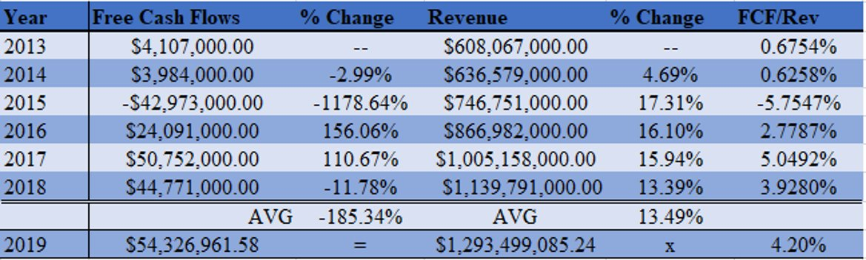
*This step was then projected out to the year 2046 with an adjusted FCF/Rev Ratio*

Step 2. The next step was determining a discount rate which is where we found the Weighted Average Cost of Capital (WACC). The WACC=E/(E/D)*cost of equity+D/(E+D)*cost of debt*(1-tax rate).
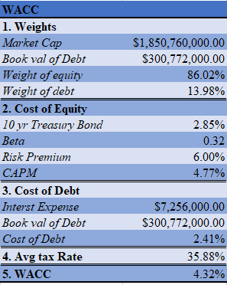

Step 3. In this step, we took the estimated free cash flows and discounted them to the present. This was done by the following formula:

DCF=FCF(YEAR)*(1/1+WACC)^(YEAR-2018))

After doing this for all years up until 2046, the discounted values were then summed up for a total short-term value of $1,762,989,271.20

Step 4. The perpetuity value can be found by the following formula:

Perpetuity=(CFn*(1+g)/(R-g))

This formula uses the last year in the short term as CFn value and discounts to the present the same way as in step 3. The algebraic value of ‘g’ is the estimated average growth rate which was taken from an in between average of historical inflation growth rates and GDP growth rates. The equation returned a perpetuity value of $ 3,915,347,580.54 which was discounted to the present at $1,198,244,987.95.

Step 5. The last step is adding the short term discounted value with the discounted perpetuity value for a total value and then dividing that by the shares outstanding for a final stock price of $72.78.

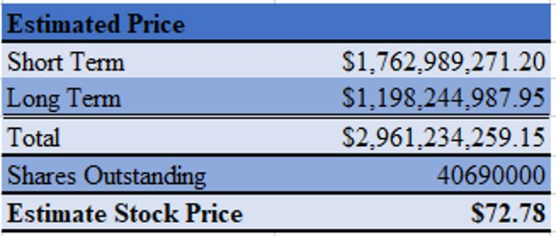

Relative Valuation

Dave & Buster’s is performing very well when looking at their relative valuation and comparing them to the industry and their main competitors. As you can tell by the from the given ratios, Dave & Buster’s is showing they are a leader in this industry.

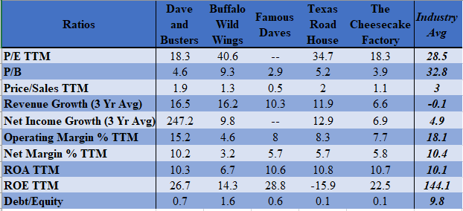

Dave & Buster’s, for the most part, is out performing their main competition and the industry average. An important aspect to look at is the change in growth from both revenue and net income over the past three years. This is a promising sign given that the industry average was a negative number for revenue growth and only about 2% of what Dave & Buster’s net income growth was. They also are showing comparable values for ROA and ROE with their competitors even though ROE is significantly below the industry average. We believe this is because the industry average came from Morningstar which also pairs large companies such as McDonalds in this group.

FINANCIAL ANALYSIS

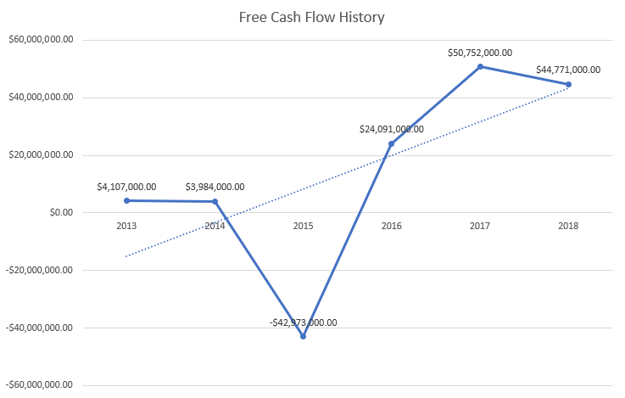

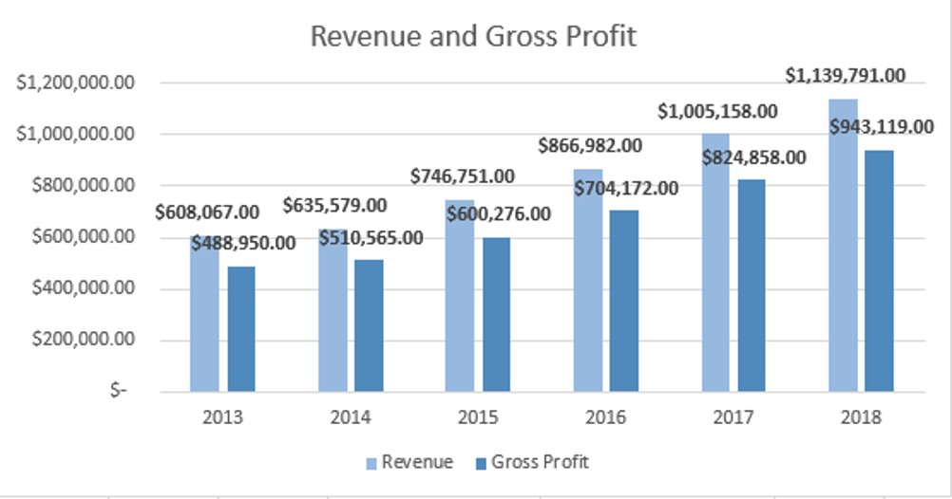

Dave & Buster’s has increased their revenue along with their gross profit since they became public back in 2014.

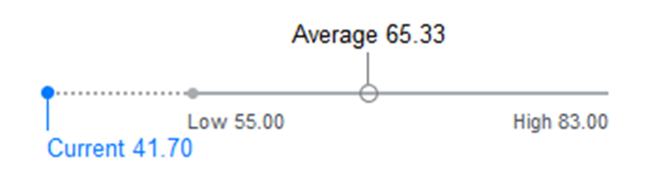
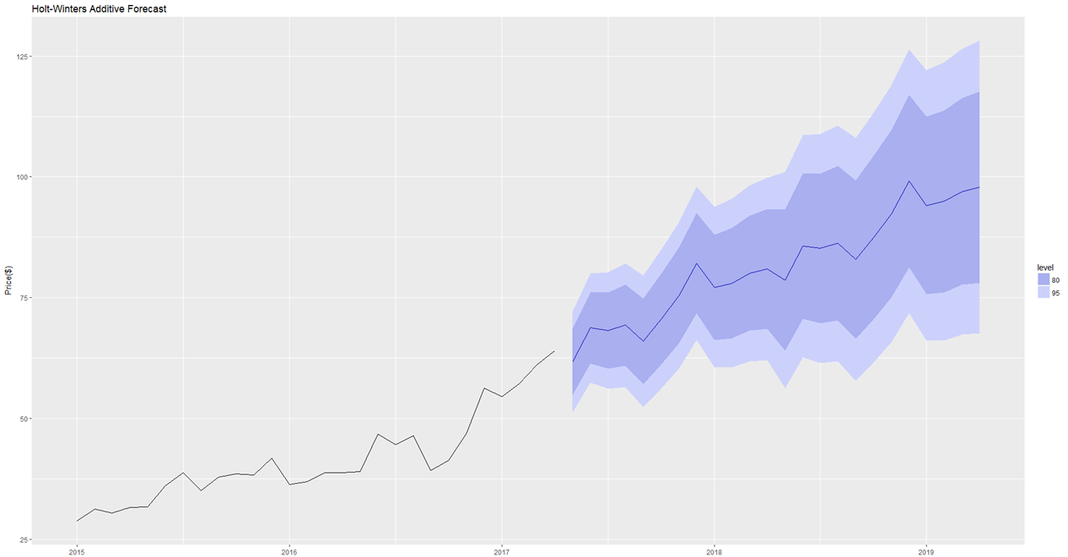
Analysts’ predictions show Dave & Buster’s Stock significantly undervalued, matching our expectations.

Our own forecasted analysis also shows Dave & Buster’s stock is projected to continually increase over the coming years. The statistical analysis of the market price of Dave & Buster’s Stock proves our forecasting model is accurate. This model was then used to forecast the next 24 months, indicating our valuation price will be achieved next April.
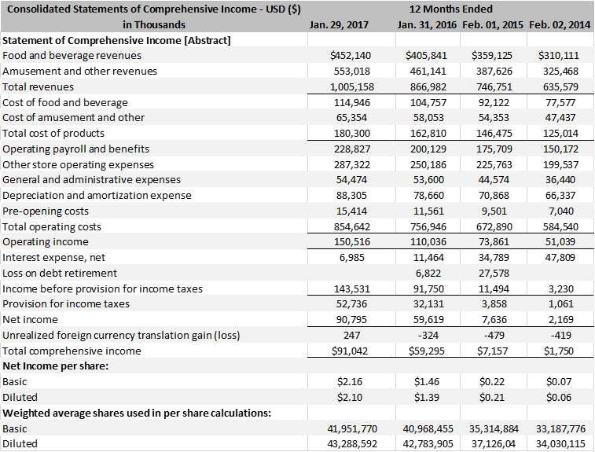
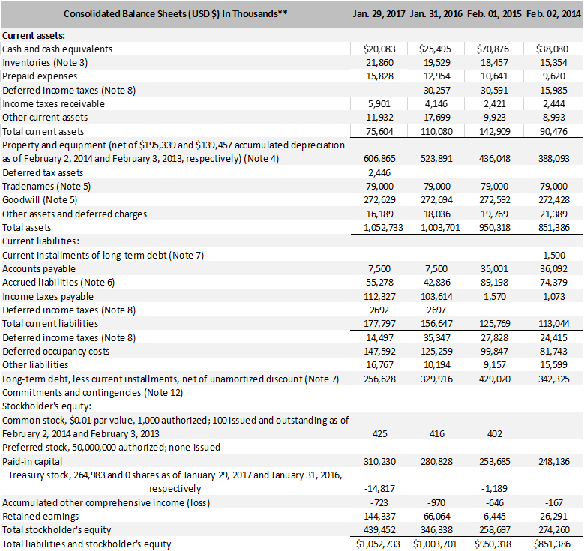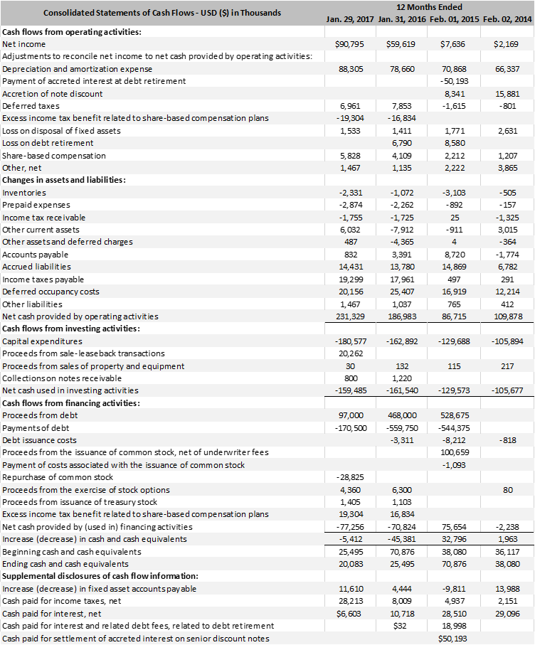
INVESTMENT RISKS

Although Dave & Buster's is faced internal and external risk. The impact of the economy is a risk in the way both casual dining and entertainment industries are driven by consumer spending. Therefore, when the economy is down, consumers have less disposable income to spend within these industries. Another risk Dave & Buster’s is faced by is the threat of competition from out-of-home localized attractions competitors including movie theaters, bowling alleys, sporting events, arcades, and restaurants. Dave & Buster's is currently implementing a growth strategy that risk are present in the way it is dependent on their ability to open new stores and operate them efficiently. When opening a store in an unfamiliar area, it is possible sales may be less than predicted. Another prominent risk is the revenue fluctuating seasonally, when the first and fourth quarter are the highest. Dave & Buster’s only having a limited supplier of games equipment is a risk in the case of absence of these suppliers.

INVESTMENT SUMMARY

Since Dave & Buster’s opened, they have developed a one of a kind business that comes with a unique back story. They are led by a dominate management team that has over 25+ years of experience in the food and gaming industry. Dave & Buster’s takes pride in the fact there is truly no other business out there like them. Having the ability to cater to so many different individual customer wants by having a one stop shop to “Eat Drink Play Watch” is something nobody can compete with. In addition, Dave & Buster’s does an excellent job by providing an exclusive restaurant design based on that specific restaurants location. With this in mind, a significant portion of their success comes from their genius growth strategy where they only put stores where they know they will become successful. It is also important to add Dave & Buster’s is constantly changing their menus and upgrading to the newest and best games on the market to keep their customers coming back for more.

After completing extensive research on this unique industry and firm as well as looking into all financials and running forecasts, we have determined Dave & Buster’s is currently underpriced and should be considered a good buy.

SOURCES

https://www.daveandbusters.com/
https://finance.yahoo.com/
https://www.gurufocus.com/term/wacc/PLAY/Weighted+Average+Cost+Of+Capital+%2528WACC%2529/Dave+%2526+Buster%2527s+Entertainment+Inc ​
http://news.morningstar.com/classroom2/course.asp?docId=145102&page=3&CN=sample
https://www.sec.gov/edgar/searchedgar/companysearch.html
https://seekingalpha.com/article/3971674-fcf-prediction-simple-method-generate-fairer-free-cash-flow-estimate?page=2

