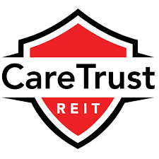

CareTrust REIT
FIN 422 Equity Research Report
Samantha McDonald, Courtney Schmaltz, Declan Walsh, Aaron Mutter

Business Description
CareTrust REIT is a self-administered, publicly traded REIT engaged in the ownership, acquisition, development and leasing of seniors housing and healthcare-related properties. CareTrust REIT was announced in 2013 and launched June 1st of 2014, as a wholly owned subsidiary of Ensign with the intent to hold substantially all of Ensign’s real estate business and become a separate independent company.
Real Estate Investment Trusts, or REIT’s, are companies that own or finance income-producing real estate across a range of property sectors. The stockholders of a REIT earn a share of the income produced through real estate investment – without having to go out and buy, manage, or finance property. REIT's have historically provided investors dividend-based income, competitive market performance, transparency, liquidity, inflation protection and portfolio diversification.
CareTrust has portfolio of properties consisting of Skilled Nursing Facilities, Assisted Living Facilities and Independent Living Facilities. Skilled Nursing Facilities are licensed healthcare facilities that provide restorative, rehabilitative and nursing care for people not requiring the more extensive and sophisticated treatment available at acute care hospitals. Assisted Living Facilities are licensed healthcare facilities that provide personal care services, support and housing for those who need help with activities of daily living, such as bathing, eating and dressing, yet require limited medical care. Independent Living Facilities, also known as retirement communities or senior apartments, are not healthcare facilities; the facilities typically consist of entirely self-contained apartment.
Management
Executive Officers
President and Chief Executive Officer
Greg Stapley
Chief Financial Officer
Bill Wagner
Chief Operating Officer
Dave Sedgwick
Chief Investment Officer
Mark Lamb
Board of Directors
President and Chief Executive Officer
Greg Stapley
Independent Director
Diana Laing
Founder and President of Clearview Hotel Capital, LLC
Jon Kline
Chairman and Chief Executive Officer of Biosynthetic Technologies, LLC
Allen Barbieri
President and Chief Executive Officer of Sabin Holdings, LLC
Spencer Plumb

Greg Stapley has served as President and CEO of CareTrust since the inception in 2014 and holds a JD from the University of Arizona, and a BA from Brigham Young University. Prior to CareTrust, he was a co-founder of Ensign, where he served as Ensign’s Executive Vice President (2009 – 2014), General Counsel (1999 – 2009) as well as Assistant Secretary shortly after it was founded in 1999. He was instrumental in assembling the real estate portfolio that was transferred to CareTrust in the Spin-Off. Stapley previously served as General Counsel for a national manufacturer, wholesaler and retailer with 192 retail outlets across the United States. Before that, Mr. Stapley was a Partner of the Phoenix law firm of Jennings, Strouss & Salmon PLC, where his practice emphasized real estate, business transactions and government relations.
Industry Overview & Competitive Positioning

The healthcare industry has had slowed growth during the past 5 years, due to an expected increase in the number of people aged 80 and up. Due to this, there has been an increase in the number of skilled nursing facilities and assisted living homes being built, creating over supply with low demand. According analyst's data, the population of people aged 80+ is expected to increase around 4% per year, as depicted by the graph below.

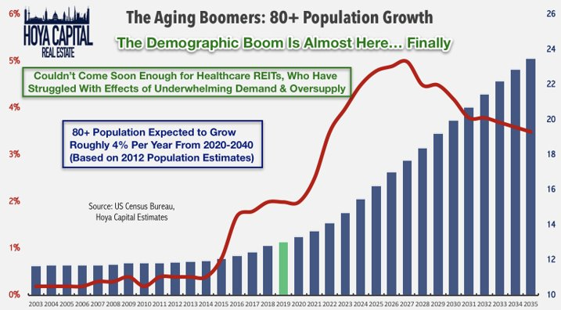
The projected growth is because the baby boomer generation is becoming of age of retirement and will require care sometime in the future. This will only be the start of healthcare needs, because everyone is going to get older, and will eventually need care at some point in their life.

As life expectancy continue to increase in the United State and seniors accounting for a higher percentage of the U.S. population, we believe the overall demand for skilled nursing services will increase. Currently the people who are 75 or older are the primary market for skilled nursing services. According to the 2012 U.S. Census, there were over 41.5 million people in the United States in 2012 that were over 65 years old. The 2012 U.S. Census estimates this group is one of the fastest growing segments in the United States population and is expected to more than double between 2000 and 2030. According to the Centers for Medicare and Medicaid Services, nursing home expenditures are projected to grow for approximately $156 billion in 2014 to approximately $274 billion in 2024, representing a compounded growth rate of 5.3%. We believe that these trends will support an increasing demand for skilled nursing services.
The growing, aging demographic is the main factor causing this increase in growth. The growth of the senior population in the United State continues to increase healthcare costs. In response, federal and state governments have encouraged the treatment of patients in a more cost-effective settings such as Skilled Nursing Facilities.
In comparison to other REIT’s the healthcare industry performs better in times of crisis. Healthcare REIT’s returns are less impacted compared to market returns in a recession. For example, the following graph shows data of different REIT sectors for a 1-year return during the 2008-2009 recession.
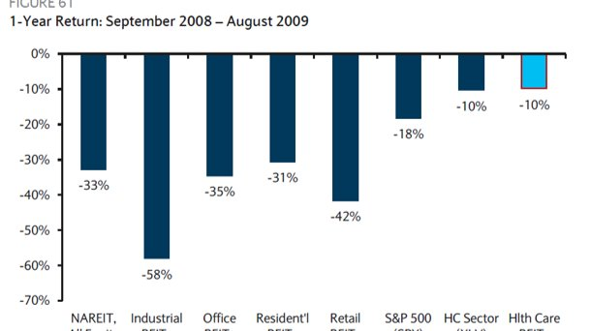
As the graph shows, Healthcare REIT’s (shaded light blue) are a safe investment in times of crisis and will help minimize risk and loss of return in a portfolio.

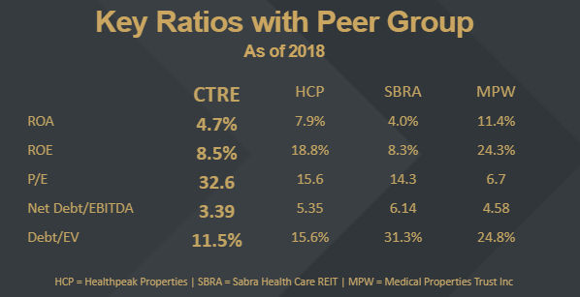
Competitors and Selected Financial Data

The peer group we decided to look at for CareTrust consisted of Healthpeak Properties, Sabra Health Care REIT, and Medical Properties Trust Inc. CareTrust is most relatable in size and financial to Sabra Health Care REIT as you can see on the Key Ratios image above. The other two companies are not on the Russel 2000. Medical Properties Trust Inc. is a great example of a company doing really well in this industry. Some key ratios to point out is CareTrust’s ROA and ROE compare well with the peer groups. CareTrust also has the lowest Debt ratios in the peer group due to managements strict policy when it comes to finding new properties to invest in. CareTrust also currently has a high P/E ratio that
Growth Strategy
Care Trust’s primary goal is to create long-term stockholder value through the payment of consistent cash dividends and growth of their asset base. To achieve this, they use a focused business strategy on opportunistic acquisitions and property diversification. They are looking to diversify their asset portfolio through acquiring new facilities and upgrading their current ones.
Due to CareTrust’s seasoned management team they have used a disciplined approach for growth mainly through the acquisition of Skilled Nursing Facilities category, now investors seem to have minimal concern today about the company’s tenant concentrations versus five year ago. Ensign, which used to account for 100% of their tenant portfolio now only accounts for around 35%. Below shows a graph of the growth of CareTrust’s properties over the past five years and projected out until 2021.
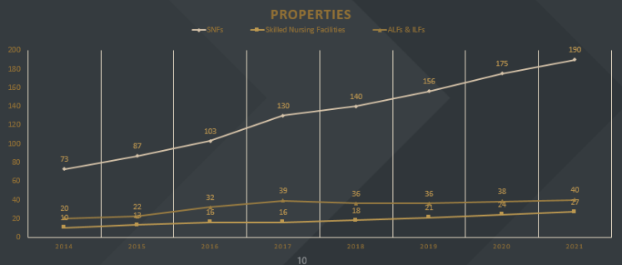
CareTrust prefers rent-stabilized assets over pure turnarounds, but assets that still have room for remaining coverage upside; as opposed to overpaying for properties that have nowhere to go but down with coverage ratios. CareTrust management has also noted that they continue to focus on smaller local/regional operators whose assets are manageable and core to the tennat’s own overall operations.

Investment Risks
CareTrust is overall a less risky as they are a part of the healthcare industry as well as the real estate industry and those are two industries people will always need. Some risks would be the overall price of senior living homes increasing as well as increasing healthcare making it hard to afford. Other potential risk factors would include competition as there is only so much market room for healthcare REIT’s. An advantage would be all the baby boomers coming to retirement age increasing the demand of healthcare real estate.
Investment Recommendation Summary
We recommend Caretrust as a strong buy, due to the high anticipation of growth and value. The aging baby boomer's generation is the main driver of this growth, and the need for assisted living will not go away. Caretrust would also add diversity to the portfolio, since there is no real estate stock in the portfolio. It is lowly correlated to the other stocks in the portfolio, with a correlation of 0.2621. Caretrust is a good addition to the portfolio that would bring in higher returns through growth.

